

**FPT Education**

**Learning Materials (FLM)**

**Software Requirement Specification**

– Hanoi, May 2023 –

**Record of changes**

| Date | A*  M, D | In charge | Change Description |
| --- | --- | --- | --- |
| 27/5/2023 | A | Trúc Hà | Thêm User Authorization  Add Functional Requirements: Account List, Account Details |
| 27/5/2023 | A | Phương Lan | Add Functionalities |
| 27/05/2023 | A | Thượng | Entities Description |
| 28/05/2023 | A | Trúc Hà | Add Functional Requirements: Curriculum List |
| 28/05/2023 | A | Thượng | Add Functional Requirements: User Login, Reset Password, New Curriculum |
| 27/05/2023 | A | Trình | Add Functional Requirements: User Profile, Change Password, Curriculum Edit. |
| 27/5/2023 | A | Dũng | Entity Relationship Diagram |
| 27/5/2023 | A | Dũng | Add Functional Requirements: Setting List, Setting Detail, Subject List |
| 28/05/2023 | A | Phương Lan | Add Functionalities |
| 28/05/2023 | A | Phuong Lan | Add Functional Requirements: Common Feature (A. User Access: Home Page, User Register) |
| 29/05/2023 | A | Trúc Hà | Add Functional Requirements: Content Group List, Content Group Details, Elective List |
| 10/6/2023 | A | Phuong Lan | Add Functional Requirements: PO List, PO Import, PO Details |
| 10/6/2023 | A | Dũng | Add Functional Requirements: New Subject, Subject Detail, Subject PLO-mapping |
| 11/6/2023 | A | Thượng | Add Functional Requirements: Subject Predecessor, subject Successor, Subject Import |
| 22/06/2023 | A | Phuong Lan | Add Functional Requirements: New Syllabus, Syllabus Import, Syllabus Edit |
| 24/06/2023 | A | Thượng | Decision List, Decision Detail, New Decision |
| 25/06/2023 | A | Dũng | CLO List, CLO Details, CLO Import |
| 25/06/2023 | A | Trúc Hà | Add Functional Requirements: Elective Details, Syllabus List, Syllabus Details |
| 25/06/2023 | A | Trình | Sesion List, Sesion Details, Sesion Import |
| 04/07/2023 | M | Trúc Hà | Modify Functional Requirements: New Syllabus, Syllabus Import, Syllabus Edit |
| 22/07/2023 | A | Dũng | New Curriculum Subject, Curriculum Subject Details |
| 22/07/2023 | M | Dũng | Modify Functional Requirements: New Subject, Subject Details |
| 22/07/2023 | A | Thượng | Decision Overview, Combo List, Combo Details, New Combo |

*A - Added M - Modified D - Deleted

**Table of Contents**

**I. Overview** 4

1. Screen Flow 4

2. Functionalities 4

3. User Authorization 4

4. Entity Relationship Diagram 5

**II. Functional Requirements**  6

1. Common Feature

A. User Access

1. Home Page
2. User Login
3. User Register
4. Reset Password
5. User Profile
6. Password Change

B. System Admin

1. Account List
2. Account Details
3. Setting List
4. Setting Details

2. Curriculums & Subjects

A. Curriculum Management

1. Curriculum List
2. New Curriculum
3. Curriculum Overview
4. Curriculum Edit

B. Subject Management

1. Subject List
2. New Subject
3. New Curriculum Subject
4. Subject Import
5. Subject -PLO Mapping
6. Curriculum Subject Details
7. Subject Details

C. Curriculum Subjects

1. Subject Predecessors
2. Subject Successors

3. Curriculums Details

A. PO Management

1. PO List
2. PO Details
3. PO Import

B. PLO Management

1. PLO List
2. PLO Details
3. PLO Import
4. PLO-PO Mapping

C. Subject Groups

1. Combo List
2. Combo Details
3. Content Group List
4. Content Group Details
5. Elective List
6. Elective Details
7. New Combo

4. Syllabus Management

A. Syllabus Management

1. Syllabus List
2. New Syllabus
3. Syllabus Import
4. Syllabus Overview
5. Syllabus Edit

B. CLO Management

1. CLO List
2. CLO Details
3. CLO Import
4. CLO-PLO Mapping

C. Training Schedule

1. Session List
2. Session Details
3. Session Import

5. Material Approvals

A. Decision Management

1. Decision List
2. Decision Details
3. New Decision
4. Decision Overview

# **I. Overview**

## **1. Screen Flow**

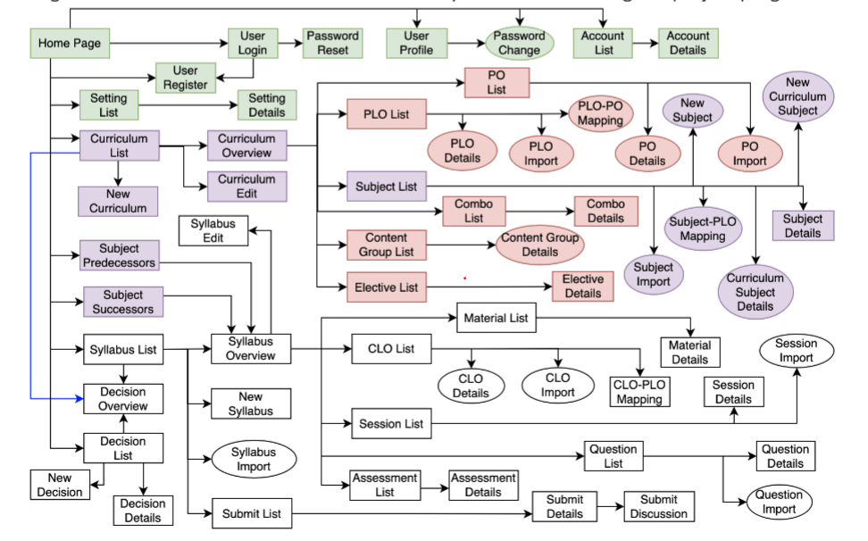

## **2. Functionalities**

| **#** | **Feature** | **Use Case** | **Screen/**  **Function** | **Screen/Function Details** |
| --- | --- | --- | --- | --- |
| 1 | Public | User are presented with an overview of the website's features | Home Page | The starting page of the system |
| 2 | Common | To log into the system, authenticate, and authorise users. | User Login | Authenticate the user to give him/her to access authorised features later on |
| 3 | Common | Allow users to reset their password when forgotten or unable to access their account. | Password Reset | Use in case the user forgot his/her password |
| 4 | Common | To register a new account within the system.Store user information in the database. | User Register | Register a new user into the system, verified by the registered email |
| 5 | Common | Allowing users to customise their preferences, settings, and content. | User Profile | View & edit/update user profile |
| 6 | Common | Allows users to update their passwords as a security measure | Password Change | Change user’s login password |
| 7 | Admin | View all account list  Search/Filter account  Activate/deactivate account  Sort account list  Paging | Account List | List, filter, search, show, hide, view, add new or edit existing Accounts (s) |
| 8 | Admin | Show all detail of account  Edit detail information of account | Account Details | View & edit the details of a specific Accounts |
| 9 | Admin | View list setting type  Search name of setting  Allow users to customise their account | Setting List | List, filter, search, show, hide, view, add new or edit existing system setting(s) |
| 10 | Admin | Edit users or assign admin | Setting Details | View, add new, delete & edit the details of a specific system setting |
| 11 | Public | View all curriculum list  Search/Filter curriculum  Paging  Sort | Curriculum List | Display a list of curricula with limited details, such as program name and a brief description. Allow browsing and selecting a curriculum to view its overview. |
| 12 | Public | View curriculum overview | Curriculum Overview | Display a list of curricula with basic information such as name, program, and description. Allow sorting and filtering options to refine the list based on specific criteria. Clicking on a curriculum entry navigates to the Curriculum Overview screen for more detailed information. |
| 13 | Admin | Add new curriculum | New Curriculum | Provide input fields to enter curriculum details such as name, program, description, and any other required information. Allow adding and associating subjects with the new curriculum. Provide validation to ensure all necessary information is provided before saving. |
| 14 | Admin | Update curriculum/curriculum detail  Delete curriculum/curriculum detail | Curriculum Edit | Display the current details of the selected curriculum. Allow editing and updating the curriculum's information, such as name, program, description, and associated subjects. Provide validation to ensure all necessary information is provided before saving. |
| 15 | Admin | View and browse the list of subjects. | Subject List | Display a list of subjects with relevant details such as subject code, name, credit hours, and any other necessary information. Allow sorting and filtering options to refine the list based on specific criteria. Clicking on a subject entry may display additional details about the subject if required. |
| 16 | Admin | The process of introducing a new subject or course into an educational | New Subject | Display a list of subjects with relevant details such as subject code, name, credit hours, and any other necessary information. Allow sorting and filtering options to refine the list based on specific criteria. Clicking on a subject entry may display additional details about the subject if required. |
| 17 | Admin | As an admin, I want to add subjects to a new curriculum. | New Curriculum Subject | Display a form to add subjects to a new curriculum. Allow searching and selecting subjects from the Subject List. Provide the ability to set the credit hours or other relevant details for each subject. |
| 18 | Admin | As an admin, I want to import subjects from an external source. | Subject Import | Provide a file upload option to import subject data in a specific format. Validate and process the imported data to add subjects to the system. Display import summary and any error messages for failed imports. |
| 19 | Admin | As an admin, I want to map Program Learning Outcomes (PLOs) to subjects. | Subject-PLO Mapping | Display a table or form to map PLOs to subjects. Allow selecting subjects and their associated PLOs from the respective lists. Provide the ability to update and save the mapping information. |
| 20 | Public | As a user, I want to view detailed information about subjects in a curriculum. | Curriculum Subject Details | Display the subject details including subject name, code, credit hours, and any other relevant information. Show the mapping of PLOs to the subject if available. |
| 21 | Public | As a user, I want to view detailed information about a specific subject. | Subject Details | Display comprehensive details of a selected subject, such as subject name, code, credit hours, syllabus, and any other relevant information. Show the mapping of PLOs to the subject if available. |
| 22 | Admin | As an admin, I want to view a list of Program Outcomes (POs). | PO List | Display a list of POs with their names and descriptions. Allow sorting and filtering options to refine the list based on specific criteria. |
| 23 | Admin | As an admin, I want to import Program Outcomes (POs) from an external source. | PO Import | Provide a file upload option to import PO data in a specific format. Validate and process the imported data to add POs to the system. Display import summary and any error messages for failed imports. |
| 24 | Public | As a user, I want to view detailed information about a specific Program Outcome (PO). | PO Details | Display comprehensive details of a selected PO, such as name, description, and any other relevant information. |
| 25 | Admin | As an admin, I want to view a list of Program Learning Outcomes (PLOs). | PLO List | Display a list of PLOs with their names and descriptions. Allow sorting and filtering options to refine the list based on specific criteria. |
| 26 | Public | As a user, I want to view detailed information about a specific Program Learning Outcome (PLO). | PLO Details | Display comprehensive details of a selected PLO, such as name, description, and any other relevant information. |
| 27 | Admin | As an admin, I want to import Program Learning Outcomes (PLOs) from an external source. | PLO Import | Provide a file upload option to import PLO data in a specific format. Validate and process the imported data to add PLOs to the system. Display import summary and any error messages for failed imports. |
| 28 | Admin | As an admin, I want to map Program Learning Outcomes (PLOs) to Program Outcomes (POs). | PLO-PO Mapping | Display a table or form to map PLOs to POs. Allow selecting PLOs and their associated POs from the respective lists. Provide the ability to update and save the mapping information. |
| 29 | Public | As a user, I want to view a list of available course combinations (combos). | Combo List | Display a list of combos with their names, descriptions, and any other relevant information.Allow sorting and filtering options to refine the list based on specific criteria. |
| 30 | Public | As a user, I want to view detailed information about a specific course combination (combo). | Combo Details | Display comprehensive details of a selected combo, such as the list of subjects included, credit hours, and any other relevant information. |
| 31 | Public | As a user, I want to view a list of content groups. | Content Group List | Display a list of content groups with their names, descriptions, and any other relevant information. Allow sorting and filtering options to refine the list based on specific criteria. |
| 32 | Public | As a user, I want to view detailed information about a specific content group. | Content Group Details | Display comprehensive details of a selected content group, including the list of subjects or content items associated with it. |
| 33 | Public | As a user, I want to view a list of available elective subjects. | Elective List | Display a list of elective subjects with their names, descriptions, and any other relevant information. Allow sorting and filtering options to refine the list based on specific criteria. |
| 34 | Public | As a user, I want to view detailed information about a specific elective subject. | Elective Details | Display comprehensive details of a selected elective subject, including subject name, code, credit hours, and any other relevant information. |
| 35 | Publicic | As a user, I want to view a list of available syllabi. | Syllabus List | Display a list of syllabi with their names, descriptions, and any other relevant information. Allow sorting and filtering options to refine the list based on specific criteria |
| 36 | Public | As a user, I want to view an overview of a specific syllabus. | Syllabus Overview | Display an overview of a selected syllabus, including program details, associated subjects, and any other relevant information. |
| 37 | Admin | As an admin, I want to edit a syllabus. | Syllabus Edit | Display a list of syllabi with their names, descriptions, and any other relevant information. Allow sorting and filtering options to refine the list based on specific criteria |
| 38 | Amin | As an admin, I want to create a new syllabus. | New Syllabus | Display a form to create a new syllabus by providing details such as program name, description, and associated subjects. Validate the entered information before saving the new syllabus. |
| 39 | Admin | As an admin, I want to import syllabus data from an external source. | Syllabus Import | Provide a file upload option to import syllabus data in a specific format. Validate and process the imported data to add syllabi to the system. Display import summary and any error messages for failed imports. |
| 40 | Public | As a user, I want to view a list of available decisions. | Decision List | Display a list of decisions with their names, descriptions, and any other relevant information. Allow sorting and filtering options to refine the list based on specific criteria. |
| 50 | Public | As a user, I want to view an overview of a specific decision. | Decision Overview | Display an overview of a selected decision, including its details, associated subjects, and any other relevant information. |
| 51 | Admin | As an admin, I want to create a new decision. | New Decision | Display a form to create a new decision by providing details such as name, description, and associated subjects. Validate the entered information before saving the new decision. |
| 52 | Public | As a user, I want to view detailed information about a specific decision. | Decision Details | Display comprehensive details of a selected decision, including its name, description, associated subjects, and any other relevant information. |
| 53 | Public | As a user, I want to view a list of submitted assignments or assessments. | Submit List | Display a list of submitted assignments or assessments with relevant details such as submission date, status, and any other relevant information. Allow sorting and filtering options to refine the list based on specific criteria. |
| 54 | Public | As a user, I want to view detailed information about a specific submission. | Submit Details | Display comprehensive details of a selected submission, including the submitted material, feedback, grades, and any other relevant information. |
| 55 | Public | As a user, I want to participate in a discussion related to a specific submission | Submit Discussion | Provide a platform for users to engage in a discussion thread specific to a submission. Allow users to post comments, reply to comments, and view the discussion history. |
| 56 | Public | As a user, I want to view a list of available course materials. | Material List | Display a list of course materials with their names, descriptions, and any other relevant information.Allow sorting and filtering options to refine the list based on specific criteria. |
| 57 | Public | As a user, I want to view detailed information about a specific course material. | Material Details | Display comprehensive details of a selected course material, including its name, description, file attachments, and any other relevant information. |
| 58 | Public | As a user, I want to view a list of Course Learning Outcomes (CLOs). | CLO List | Display a list of CLOs with their names, descriptions, and any other relevant information. Allow sorting and filtering options to refine the list based on specific criteria. |
| 59 | Public | As a user, I want to view detailed information about a specific Course | CLO Details | Display comprehensive details of a selected CLO, including its name, description, and any other relevant information. |
| 60 | Admin | As an admin, I want to import Course Learning Outcomes (CLOs) from an external source. | CLO Import | Provide a file upload option to import CLO data in a specific format. Validate and process the imported data to add CLOs to the system. Display import summary and any error messages for failed imports. |
| 61 | Admin | As an admin, I want to map Course Learning Outcomes (CLOs) to Program | CLO-PLO Mapping | Display a table or form to map CLOs to PLOs. Allow selecting CLOs and their associated PLOs from the respective lists. Provide the ability to update and save the mapping information. |
| 62 | Public | As a user, I want to view a list of sessions or classes. | Session List | Display a list of sessions or classes with relevant details such as session name, date, time, and any other relevant information. Allow sorting and filtering options to refine the list based on specific criteria. |
| 63 | Public | As a user, I want to view detailed information about a specific session or class. | Session Details | Display comprehensive details of a selected session or class, including its name, date, time, location, and any other relevant information. |
| 64 | Admin | As an admin, I want to import session data from an external source. | Session Import | Provide a file upload option to import session data in a specific format. Validate and process the imported data to add sessions to the system. Display import summary and any error messages for failed imports. |
| 65 | Public | As a user, I want to view a list of available questions or quizzes. | Question List | Display a list of questions or quizzes with their names, descriptions, and any other relevant information.  Allow sorting and filtering options to refine the list based on specific criteria. |
| 66 | Public | As a user, I want to view detailed information about a specific question or quiz. | Question Details | Display comprehensive details of a selected question or quiz, including its content, options, correct answer, and any other relevant information. |
| 67 | Admin | As an admin, I want to import question data from an external source. | Question Import | Provide a file upload option to import question data in a specific format. Validate and process the imported data to add questions to the system. Display import summary and any error messages for failed imports. |
| 68 | Public | As a user, I want to view a list of assessments or exams. | Assessment List | Display a list of assessments or exams with their names, descriptions, and any other relevant information. Allow sorting and filtering options to refine the list based on specific criteria. |
| 69 | Public | As a user, I want to view detailed information about a specific assessment or exam. | Assessment Details | Display comprehensive details of a selected assessment or exam, including its name, description, duration, instructions, and any other relevant information. |
| 70 | Public | As a user, I want to view a list of subjects that are prerequisites for a specific subject. | Subject Predecessors | Display a list of subjects that are required as prerequisites for a selected subject. Provide information about each prerequisite subject, such as subject code, name, and any other relevant details. |
| 71 | Public | As a user, I want to view a list of subjects for which a specific subject is a prerequisite. | Subject Successors | Display a list of subjects for which the selected subject is listed as a prerequisite. Provide information about each successor subject, such as subject code, name, and any other relevant details. |

## **3. User Authorization**

| **Screen** | **Guest** | **System Admin** | **CRDD Head** | **CRDD Staff** | **Syllabus Designer** | **Syllabus Reviewer** | **Student** | **Teacher** |
| --- | --- | --- | --- | --- | --- | --- | --- | --- |
| Homepage | X | X | X | X | X | X | X | X |
| User Login | X | X | X | X | X | X | X | X |
| Password Reset |  | X | X | X | X | X | X | X |
| User Register | X | X | X | X | X | X | X | X |
| User Profile |  | X | X | X | X | X | X | X |
| Password Change |  | X | X | X | X | X | X | X |
| Account List |  | X |  |  |  |  |  |  |
| Account Details |  | X |  |  |  |  |  |  |
| Setting List |  | X |  |  |  |  |  |  |
| Setting Details |  | X |  |  |  |  |  |  |
| Curriculum List | X | X | X | X | X | X | X | X |
| Curriculum Overview | X | X | X | X | X | X | X | X |
| New Curriculum |  | X | X | X |  |  |  |  |
| Curriculum Edit |  | X | X | X |  |  |  |  |
| Subject List |  | X | X | X | X | X | X | X |
| New Subject |  | X | X | X |  |  |  |  |
| New Curriculum Subject |  | X | X | X |  |  |  |  |
| Subject Import |  | X | X | X |  |  |  |  |
| Subject-PLO Mapping |  | X | X | X | X | X | X | X |
| Curriculum Subject Details |  | X | X | X | X | X | X | X |
| Subject Details |  | X | X | X | X | X | X | X |
| PO List |  | X | X | X | X | X | X | X |
| PO Import |  | X | X | X |  |  |  |  |
| PO Details |  | X | X | X | X | X | X | X |
| PLO List |  | X | X | X | X | X | X | X |
| PLO Details |  | X | X | X | X | X | X | X |
| PLO Import |  | X | X | X |  |  |  |  |
| PLO-PO Mapping |  | X | X | X | X | X | X | X |
| Combo List |  | X | X | X | X | X | X | X |
| Combo Details |  | X | X | X | X | X | X | X |
| Content Group List |  | X | X | X | X | X | X | X |
| Content Group Details |  | X | X | X | X | X | X | X |
| Elective List |  | X | X | X | X | X | X | X |
| Elective Details |  | X | X | X | X | X | X | X |
| Syllabus List |  | X | X | X | X | X | X | X |
| Syllabus Overview |  | X | X | X | X | X | X | X |
| Syllabus Edit |  | X | X | X |  |  |  |  |
| New Syllabus |  | X | X | X |  |  |  |  |
| Syllabus Import |  | X | X | X | X | X | X | X |
| Decision List |  | X | X | X | X | X | X | X |
| Decision Overview |  | X | X | X | X | X | X | X |
| New Decision |  | X | X | X |  |  |  |  |
| Decision Details |  | X | X | X | X | X | X | X |
| Submit List |  | X | X | X | X | X | X | X |
| Submit Details |  | X | X | X | X | X | X | X |
| Submit Discussion |  | X | X | X | X | X | X | X |
| Material List |  | X | X | X | X | X | X | X |
| Material Details |  | X | X | X | X | X | X | X |
| CLO List |  | X | X | X | X | X | X | X |
| CLO Details |  | X | X | X | X | X | X | X |
| CLO Import |  | X | X | X | X | X | X | X |
| CLO-PLO Mapping |  | X | X | X | X | X | X | X |
| Session List |  | X | X | X | X | X | X | X |
| Session Details |  | X | X | X | X | X | X | X |
| Session Import |  | X | X | X | X | X | X | X |
| Question List |  | X | X | X | X | X | X | X |
| Question Details |  | X | X | X | X | X | X | X |
| Question Import |  | X | X | X |  |  |  |  |
| Assessment List |  | X | X | X | X | X | X | X |
| Assessment Details |  | X | X | X | X | X | X | X |
| Subject Predecessors | X | X | X | X | X | X | X | X |
| Subject Successors | X | X | X | X | X | X | X | X |

## **4. Entity Relationship Diagram**

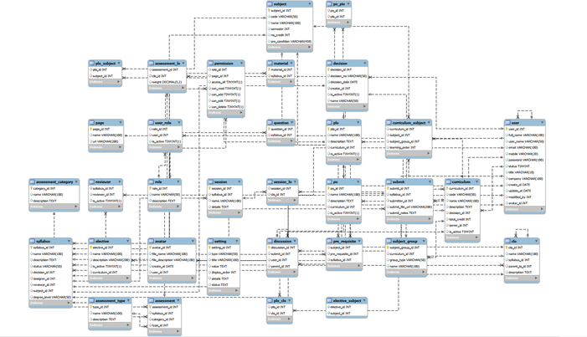

**Entities Description**

| **#** | **Entity** | **Description** |
| --- | --- | --- |
| 1 | User | a user registers, login and has access to the system. |
| 2 | User_role | the role of a user determined by their privileges and responsibilities within the system. |
| 3 | Role | a set of privileges and responsibilities granted to a user to perform core activities within the system. |
| 4 | Curriculum | a teaching program designed to help learners achieve specific learning goals. |
| 5 | Curriculum_subject | the subjects listed in a teaching program. |
| 6 | Assessment | a test or evaluation designed to measure a learner's knowledge or performance. |
| 7 | Assessment category | the type of test or evaluation, such as a written test or multiple-choice test. |
| 8 | Assessment lo | specific learning objectives assessed in a test or evaluation. |
| 9 | Assessment type | the type of test or evaluation, such as a multiple-choice test or essay. |
| 10 | Avatar | a profile picture used to represent a user in the system. |
| 11 | Clo | specific learning objectives related to the teaching program. |
| 12 | Decision | a decision made by a user or the system |
| 13 | Discussion | a forum for users to discuss and exchange opinions with each other. |
| 14 | Elective | an optional course that is not mandatory. |
| 15 | Elective subject | optional subjects that are not mandatory. |
| 16 | Material | teaching materials, such as textbooks or lectures. |
| 17 | Page | optional subjects that are not mandatory. |
| 18 | Permission | access rights to features or functions of the system granted to users. |
| 19 | Plo | specific learning objectives related to the teaching program. |
| 20 | Plo clo | the relationship between specific learning objectives and overall learning objectives  related to the teaching program. |
| 21 | Plo subject | the relationship between overall learning objectives and the subjects in the teaching  program |
| 22 | Po | overall learning objectives related to the teaching program. |
| 23 | Po plo | the relationship between overall learning objectives and specific learning objectives  related to the teaching program |
| 24 | Pre_requisite | courses or skills required to participate in a course or program. |
| 25 | Question | a question used in a test or evaluation. |
| 26 | Reviewer | a user with the right to review and evaluate a submitted test or evaluation within the  system |
| 27 | Session | a working or learning session established within the system |
| 28 | Session lo | specific learning objectives related to a working or learning session. |
| 29 | Setting | the system settings to adjust features and functions. |
| 30 | Subject | a specific topic taught in a course or teaching program. |
| 31 | Subject group | a group of related subjects or arranged according to some criteria. |
| 32 | Submit | the action of submitting a test or evaluation within the system. |
| 33 | Syllabus | a document that describes in detail the courses, topics, and teaching content in a  teaching program or course |

# **II. Functional Requirements**

1. **Common Feature**
2. **User Access**
3. **Home Page**

* **Function Trigger:** This function is triggered when the user visits the website or the system homepage
* **Function Description:** Users view the system's home page to log in or register for an account
* **Screen layout:** simulate the prototype of the screen, the sample below is for the main screen

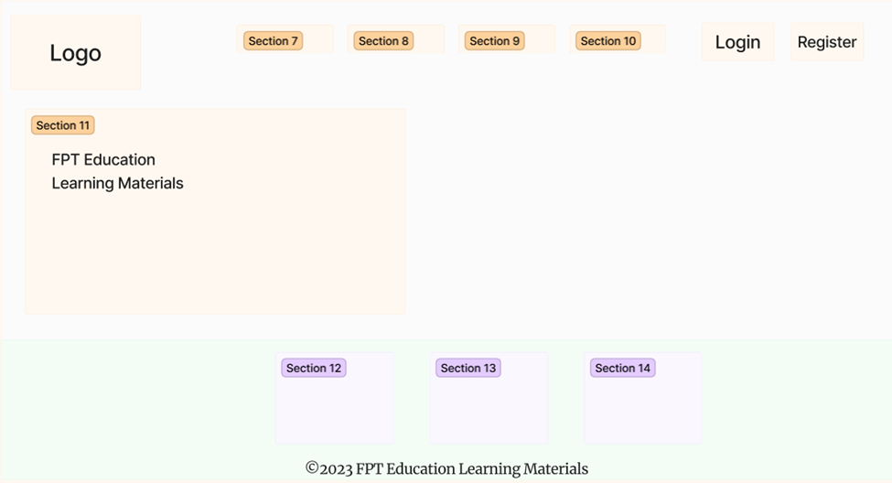

* **Function Details:** When users access the system, the homepage will appear and show information about the system

1. **User Login**

* **Function trigger**: This function is triggered when the user clicks Sign in from Homepage
* **Function description**: User sign in into the system.
* **Screen layout**: mock-up prototype of the screen, sample below is for the Sign in screen

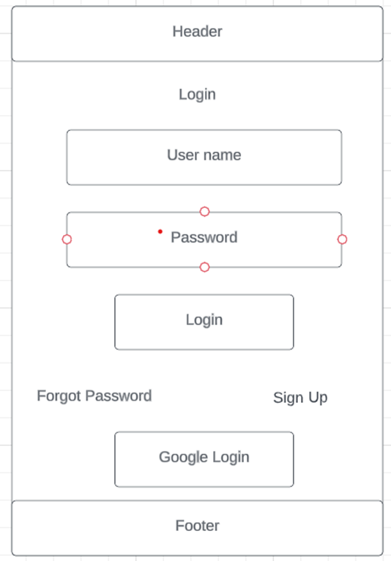

* **Function Details**: When the user is in the state not logged in, at the home page there will be a Sign in button after signing in into the system, the Sign in button will become Sign out.

1. **User Register**

* **Function trigger:** This function is triggered when the guest goes to login and choose to register
* **Function description:** The guest can create an account.
* **Screen layout:** mock-up prototype of the screen, sample below is for the Register

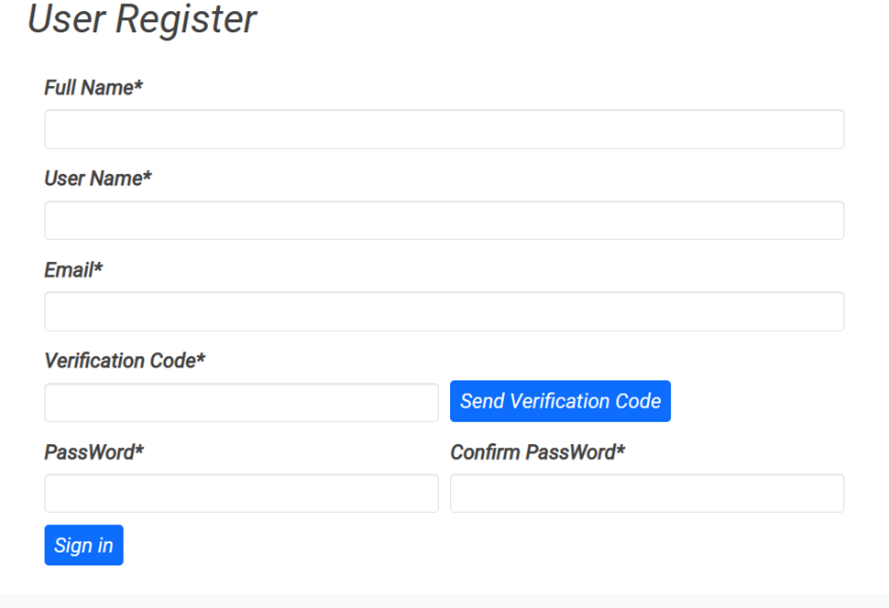

* **Function Details**: After going to the login, the guest can create an account.

1. **Reset Password**

* **Function trigger**: This function is triggered when the user clicks Forgot Password from Login
* **Function description**: User reset password into the system.
* **Screen layout**: mock-up prototype of the screen, sample below is for the reset password screen

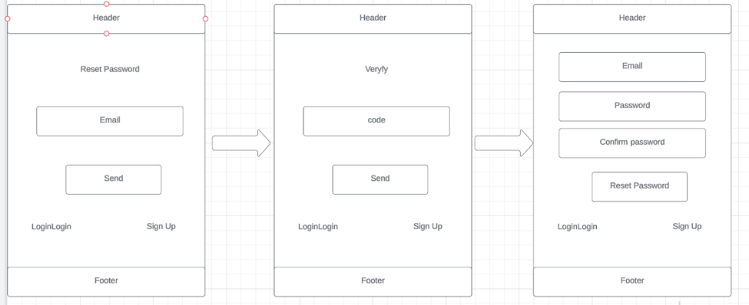

● **Function Details**: When a user forgets his password and can't log in, there is a link to forget his password when he logs in, click to change his password and log back in again.

1. **User Profile**

* **Function trigger**: This function is activated when the accounts are successfully entered (including all accounts) and can view and update more information as you want.
* **Function description**: Every account after logging in can update their information.
* **Screen layout**: simulated prototype of the screen, sample below is for all users.

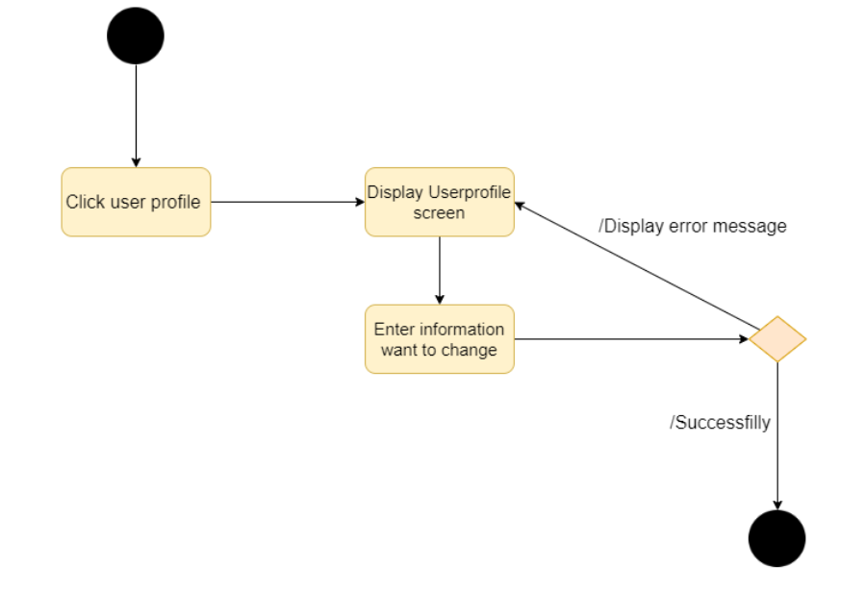

* **Function details:** Allows people to update information after registration

1. **Change Password**

* **Function trigger**: This function is activated when the accounts are successfully entered (including all accounts) and can update your current password
* **Function description**: Every account after logging in can update their desired password again.
* **Screen layout**: simulated prototype of the screen, sample below is for all users.

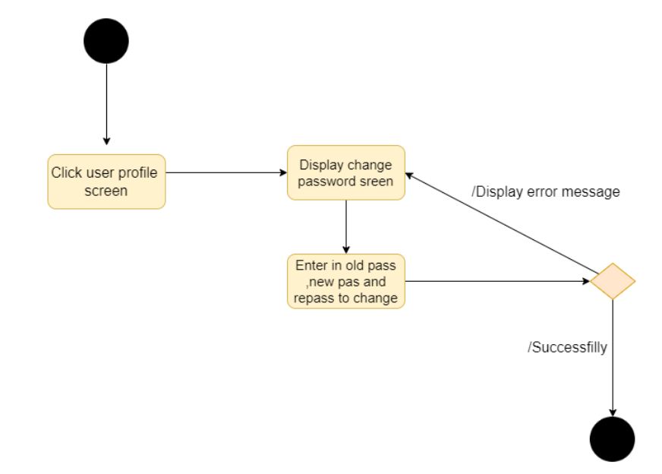

* **Function details:** Allow people to update their password after logging in

1. **System Admin**
2. **Account List**

* **Function Trigger**: When a user logs in as admin, the user chooses Dashboard then chooses User management feature on the sub header
* **Function Description**: Account list feature displays a list of all accounts created on the system including accounts of all roles.
* **Screen layout**: simulated prototype of screen, below sample is for account list screen

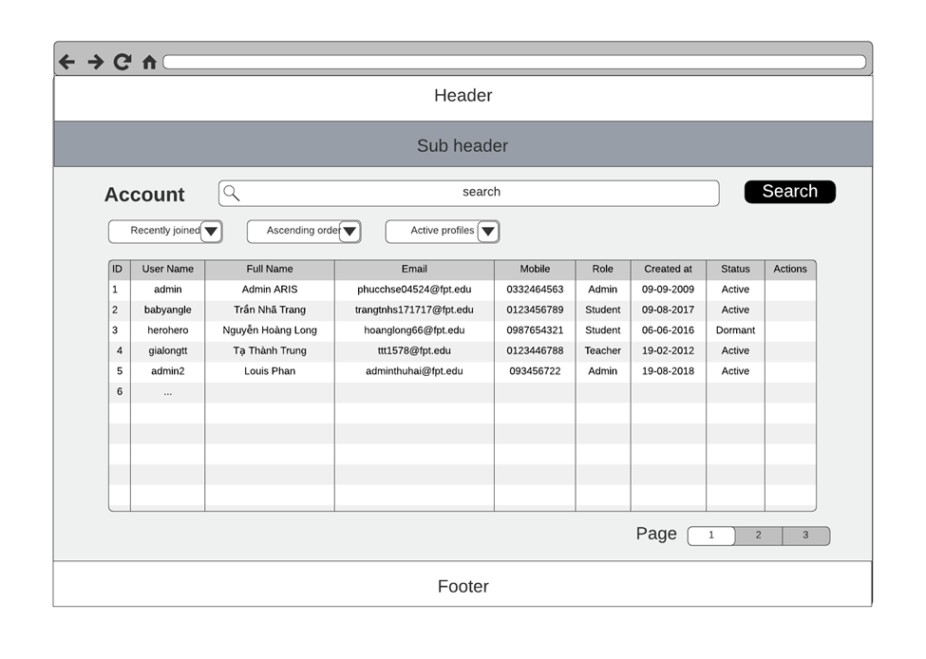

* **Function Details**: Allow the admin to search account name, display list account, edit account, sort account list of Admin, Student or Teacher

1. **Account Detail**

* **Function Trigger**: When a user logs in as admin, the user chooses Dashboard then chooses User management feature on the sub header and click on an account in list account to see detail information
* **Function Description**: Account detail feature displays user details information
* **Screen layout**: simulated prototype of screen, below sample is for account detail screen

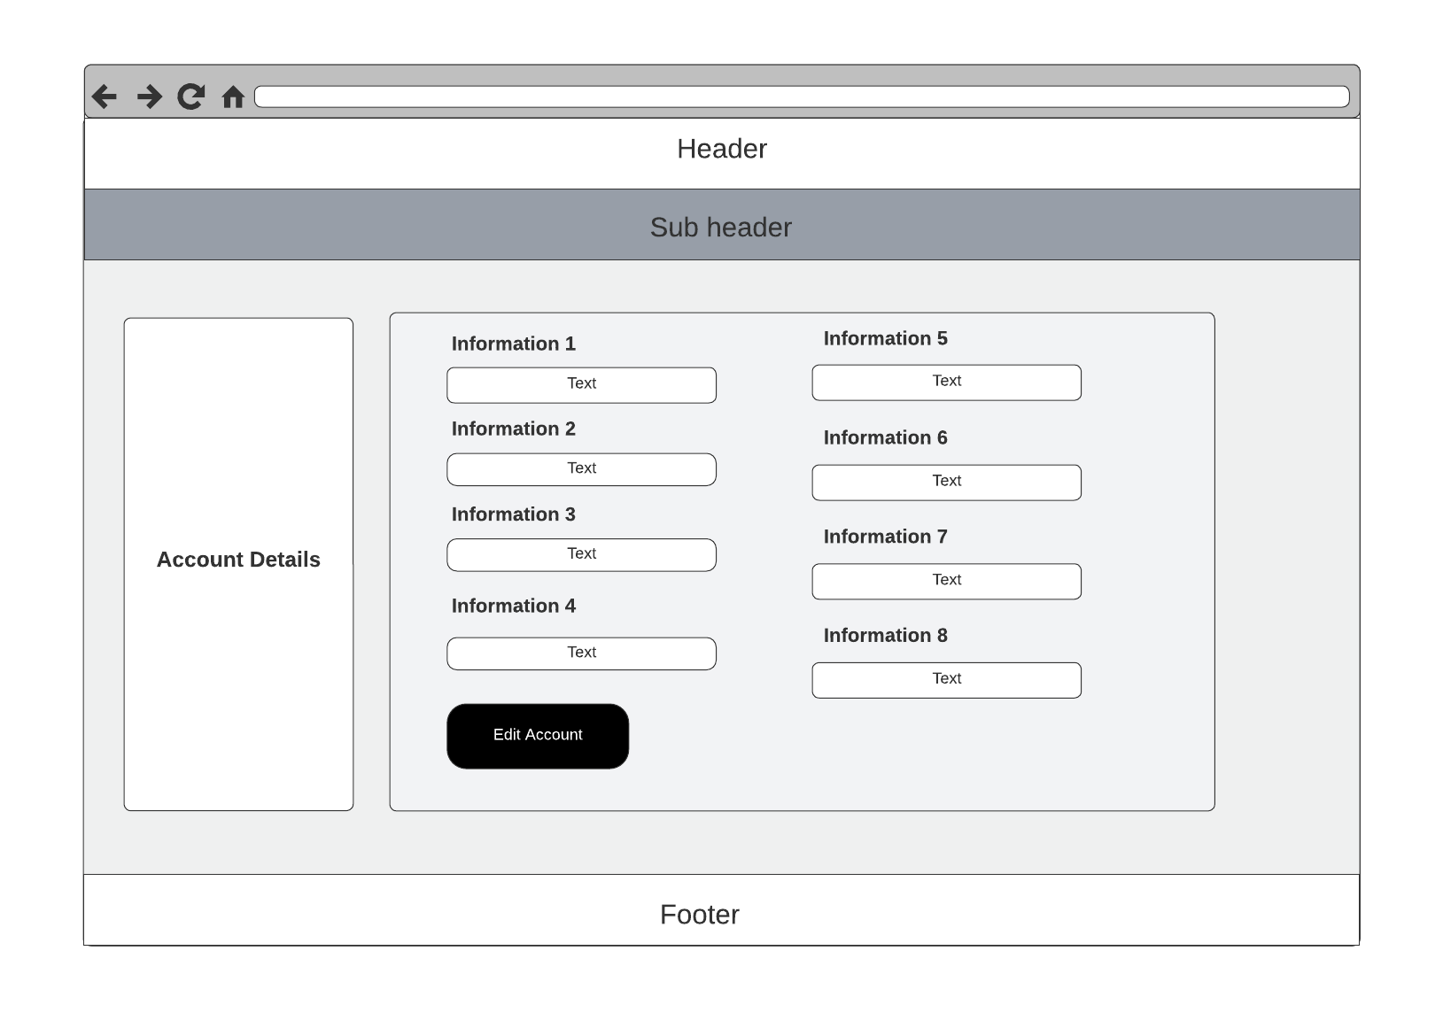

* **Function Details**: Allow the admin can view and edit user accounts in the FLM system

1. **Setting List**

**c.1. Show Setting List**

* **Function Trigger**: This function is triggered when the admin logs in successfully and chooses 'System Setting' after returning to the home page.
* **Function description**: The admin can create, find, edit, block or unlock an account.
* **Screen layout**: mock-up prototype of the screen, sample below is for the Setting List

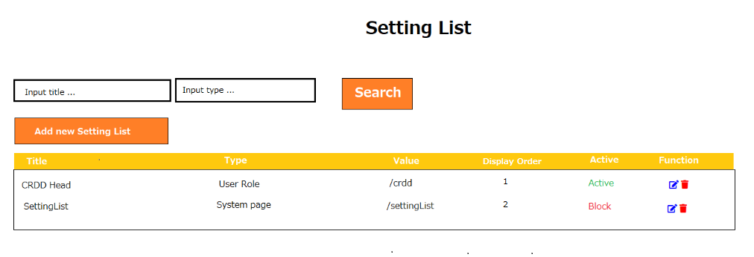

* **Function Details**: Allow the admin to search settings by title and type, from each setting, the admin can choose to view, activate/deactivate, or edit it.

**c.2. Add New Setting**

* **Function trigger**: This function is activated when the user clicks on button add
* **Function description**: add new setting
* **Screen layout**: simulated prototype of screen, below sample is for add setting screen

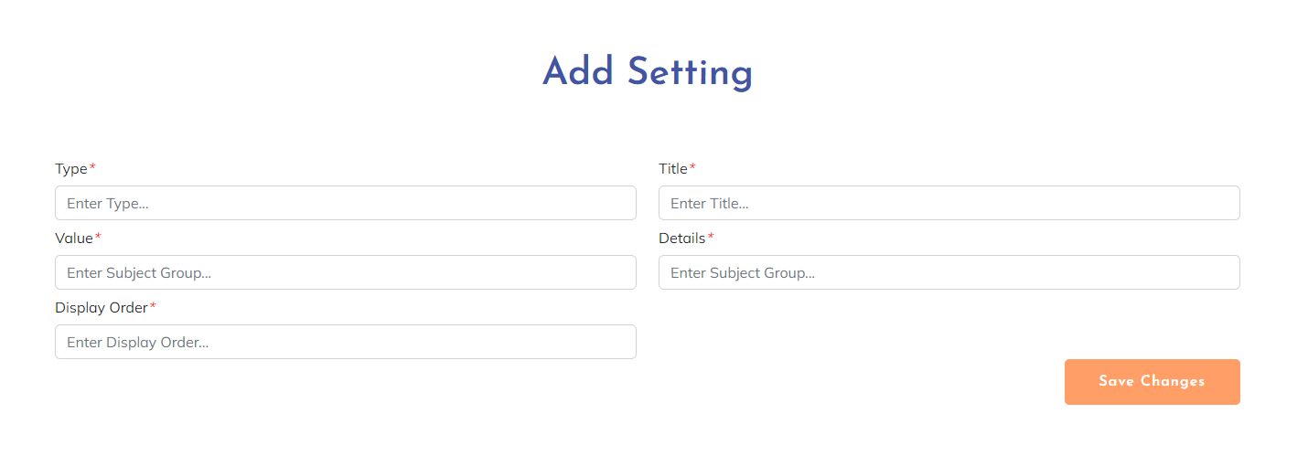

* **Function Details**: The user can add new setting

1. **Setting Details**

* **Function trigger**: This function is triggered when the admin logs in successfully and chooses 'System Setting' after returning to the home page and clicking the title.
* **Function description**: The admin can read an account.
* **Screen layout**: mock-up prototype of the screen, sample below is for the Setting Detail

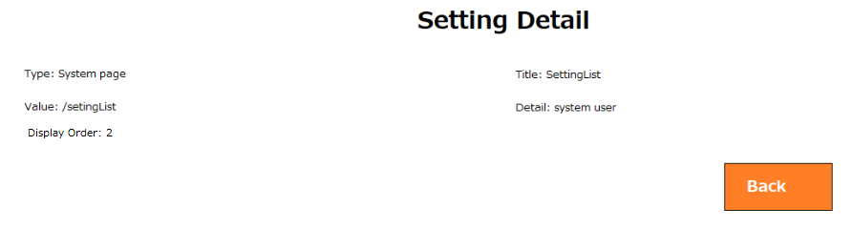

* **Function Details**: The user can see the details of the settings

**2. Curriculums & Subjects**

1. **Curriculum Management**
2. **Curriculum List**

* **Function Trigger**: Everyone access to the web page can access to this function when they choose Curriculum on the header
* **Function Description**: Curriculum list display information about all of the curriculum of the system
* **Screen layout**: simulated prototype of screen, below sample is for curriculum list screen

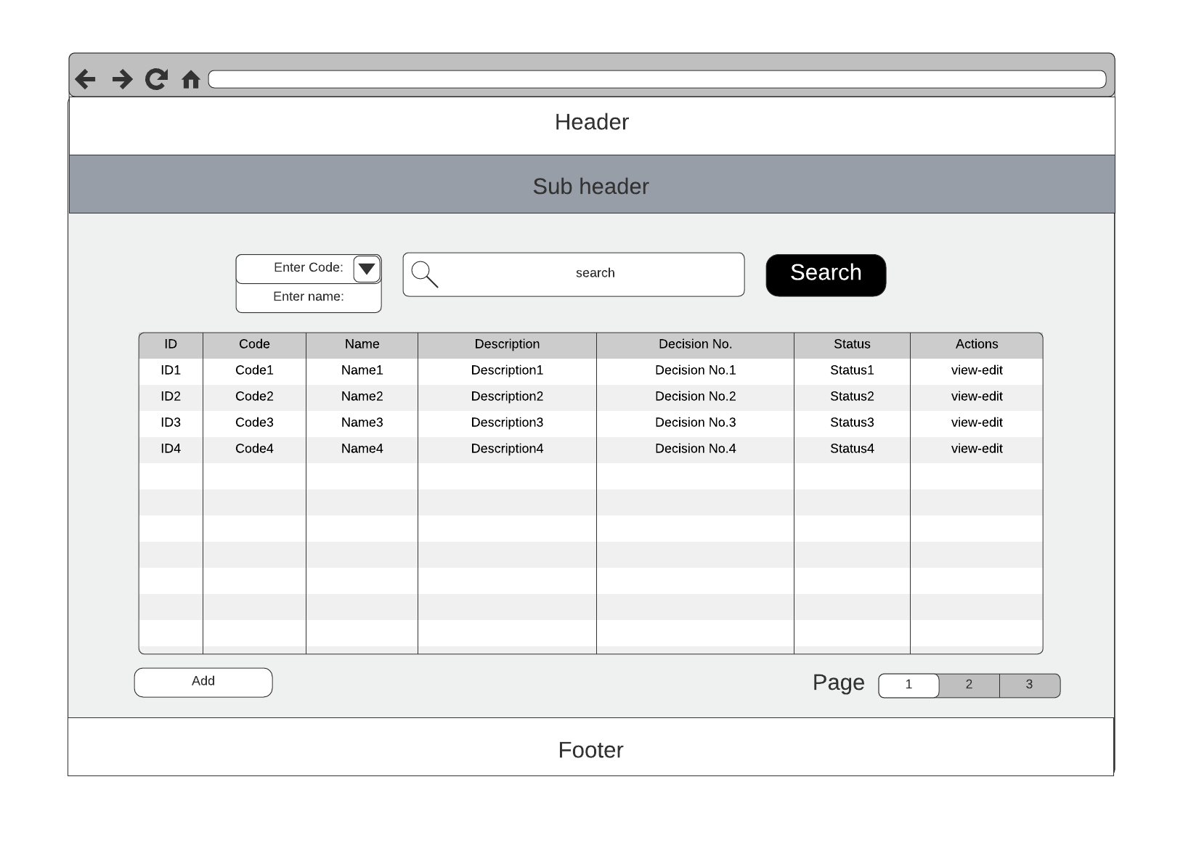

* **Function Details**: Allow every person who accesses the web page to view curriculum list and curriculum detail when clicking on the view button of corresponding curriculum. Admin can access to edit and add curriculum when they choose the button to do that action.

**b. New Curriculum**

* **Function trigger**: This function is triggered when the user clicks New curriculum from Curriculum List
* **Function description**: New Curriculum into the system.
* **Screen layout**: mock-up prototype of the screen, sample below is for the reset password screen

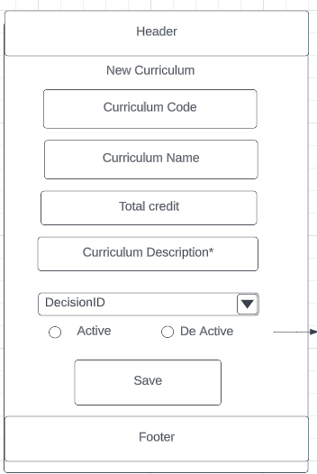

● **Function Details**: When the system administrator wants to add a curriculum, just click on the new curriculum, enter the curriculum information on the page and click save to add the new curriculum to the system.

**c. Curriculum Overview**

* **Function trigger**: This function is triggered when the user clicks View from Curriculum List
* **Function description**: View curriculum overview.
* **Screen layout**: mock-up prototype of the screen, sample below is for the curriculum overview screen

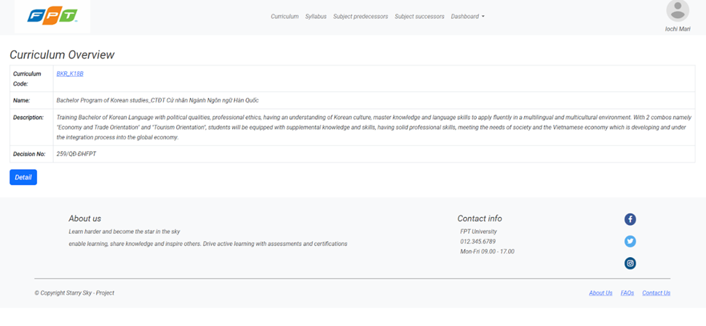

* **Function details**: Allow user to view curriculum basic information

**d. Curriculum Edit**

* **Function trigger**: This function is activated when the person who has an admin account can access it and update the information
* **Function description**: Only admin account can update information
* **Screen layout**: simulated prototype of the screen, sample below is for admin,

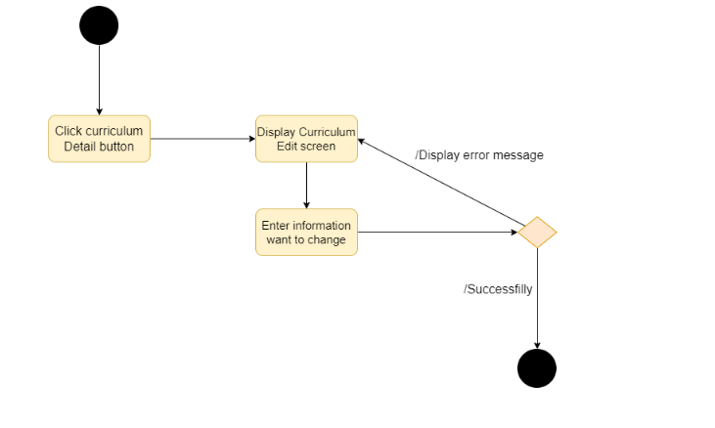

* **Function details**: Allow admin to update information after login

**B. Subject Management**

1. **Subject List**

* **Function trigger**: This function is triggered when the admin logs in successfully and chooses Curriculum view page and choice function view of curriculum after choice SubjectList.
* **Function description**: The admin can find a subject.
* **Screen layout**: mock-up prototype of the screen, sample below is for the Setting List

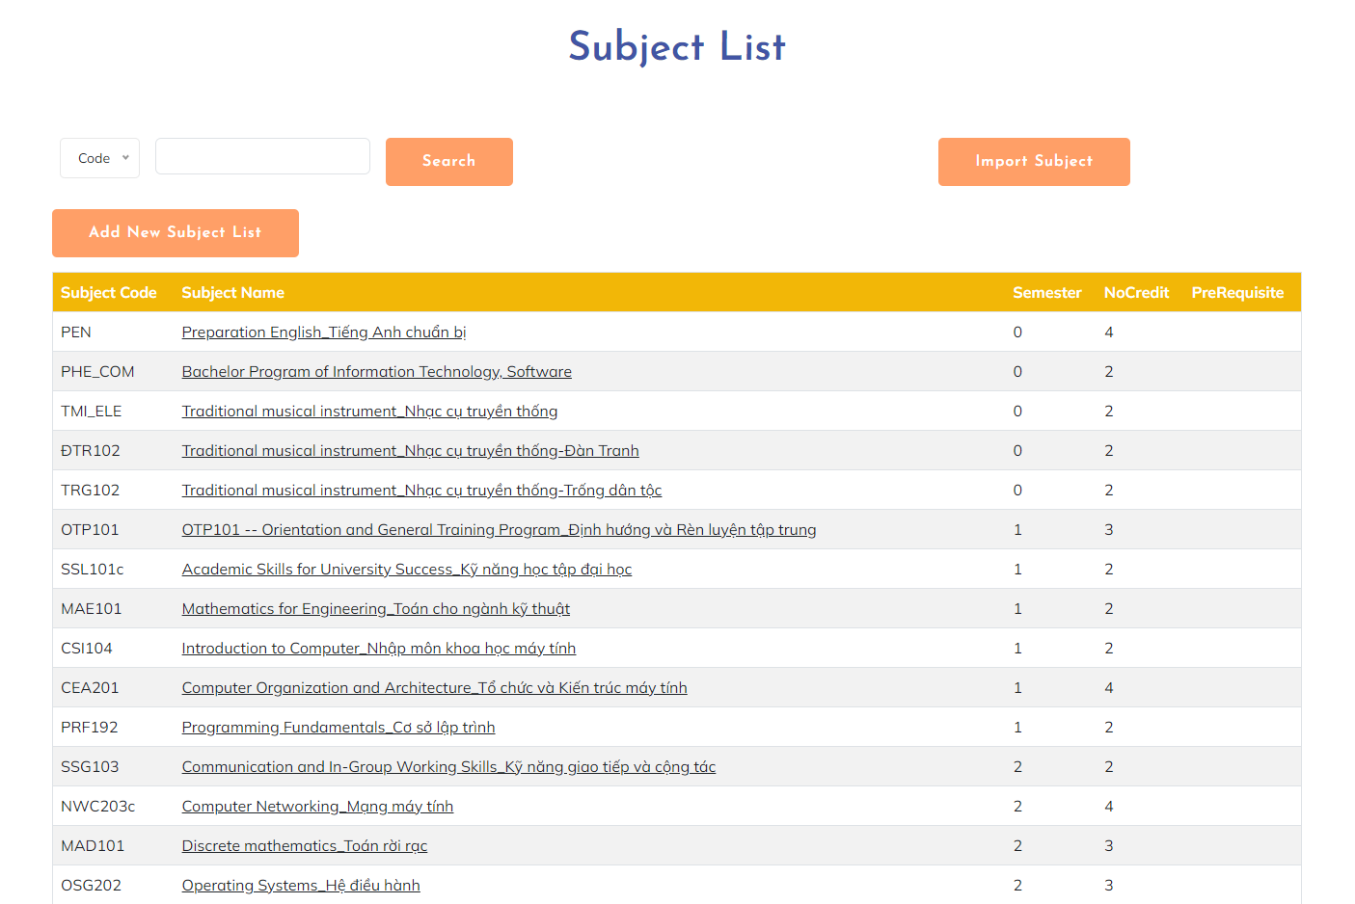

* **Function Details**: Allow the admin to search subject by code or name

1. **New Subject**

* **Function trigger**: This function is triggered when the admin logs in successfully and chooses the Manage Subjects page and selects Add New Subject List.
* **Function description**: The admin can add a subject.
* **Screen layout**:

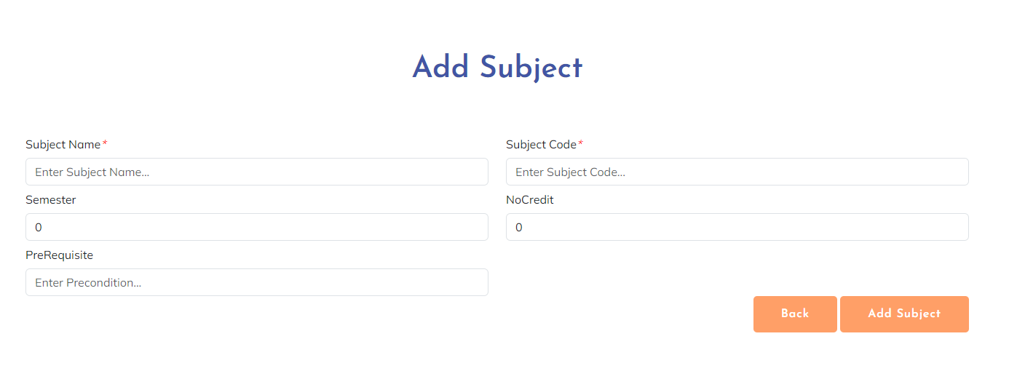

* **Functional Details**: The admin can add new subjects.

1. **New Curriculum Subject**

* **Function trigger**: This function is triggered when the admin logs in successfully and chooses Manage Subjects page and choice function view of curriculum after choosing Curriculum Subject List and selecting Add New Curriculum Subject.
* **Function description**: The admin can add a subject to Curriculum Subject.
* **Screen layout**: 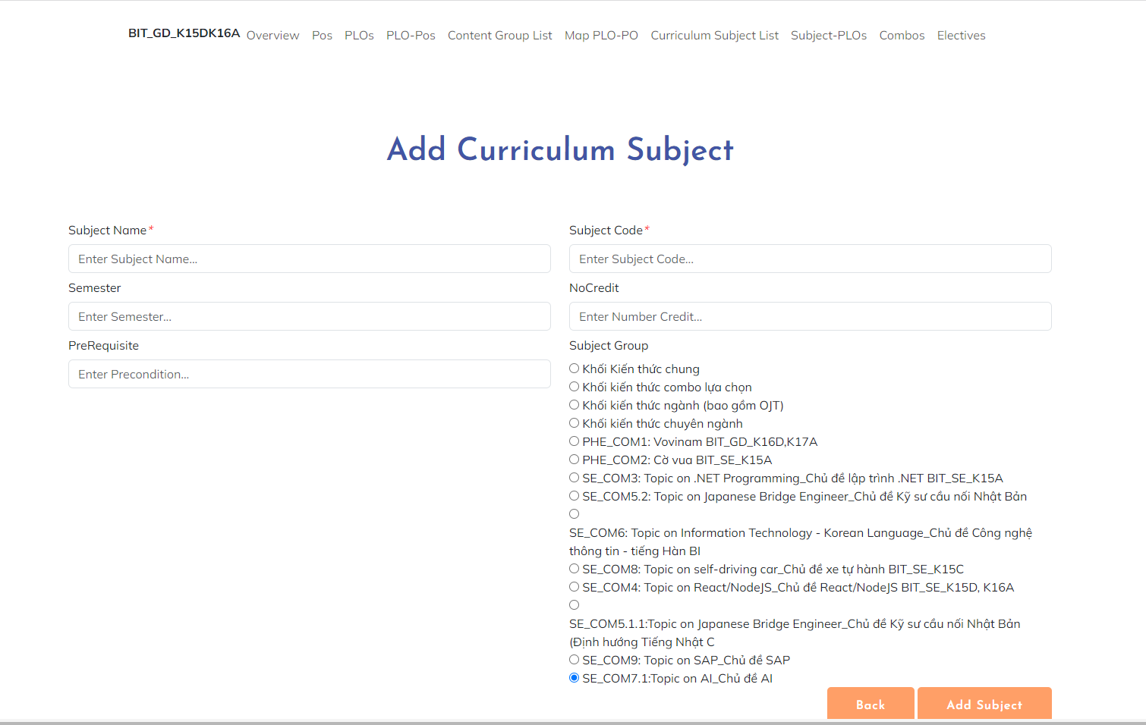
* **Functional Details**: The admin can add new subjects to Curriculum Subject.

1. **Subject Import**

* **Function trigger**: When people manage website access, they can access this functionality when they choose in site content
* **Function description**: it will be able to import data from excel into database and display in subject list
* **Screen layout**: simulated prototype of screen, below sample is for Subject import screen

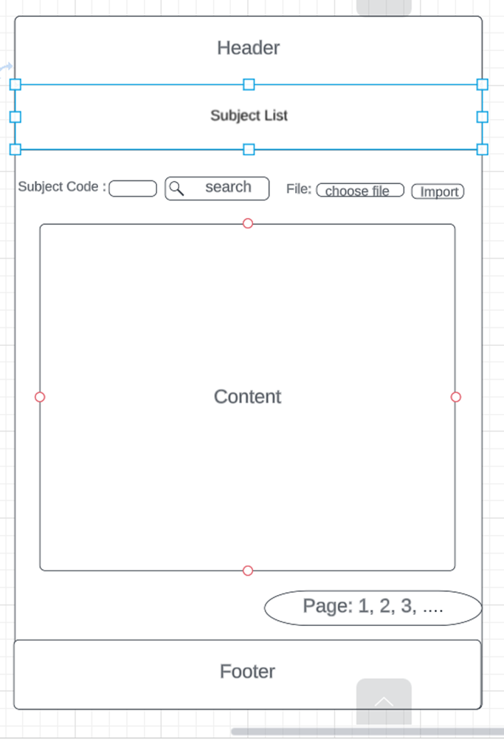

* **Functional Details**: Only administrators who log into the website will display course management and can see the course entry button in the course management section (others do not).

1. **Subject -PLO Mapping**

* **Function trigger**: This function is triggered when the admin logs in successfully and chooses Curriculum page and choice function view of curriculum after choosing Subject-PLOs
* **Function description**: The admin can edit the PLO corresponding to the subjects
* **Screen layout**: 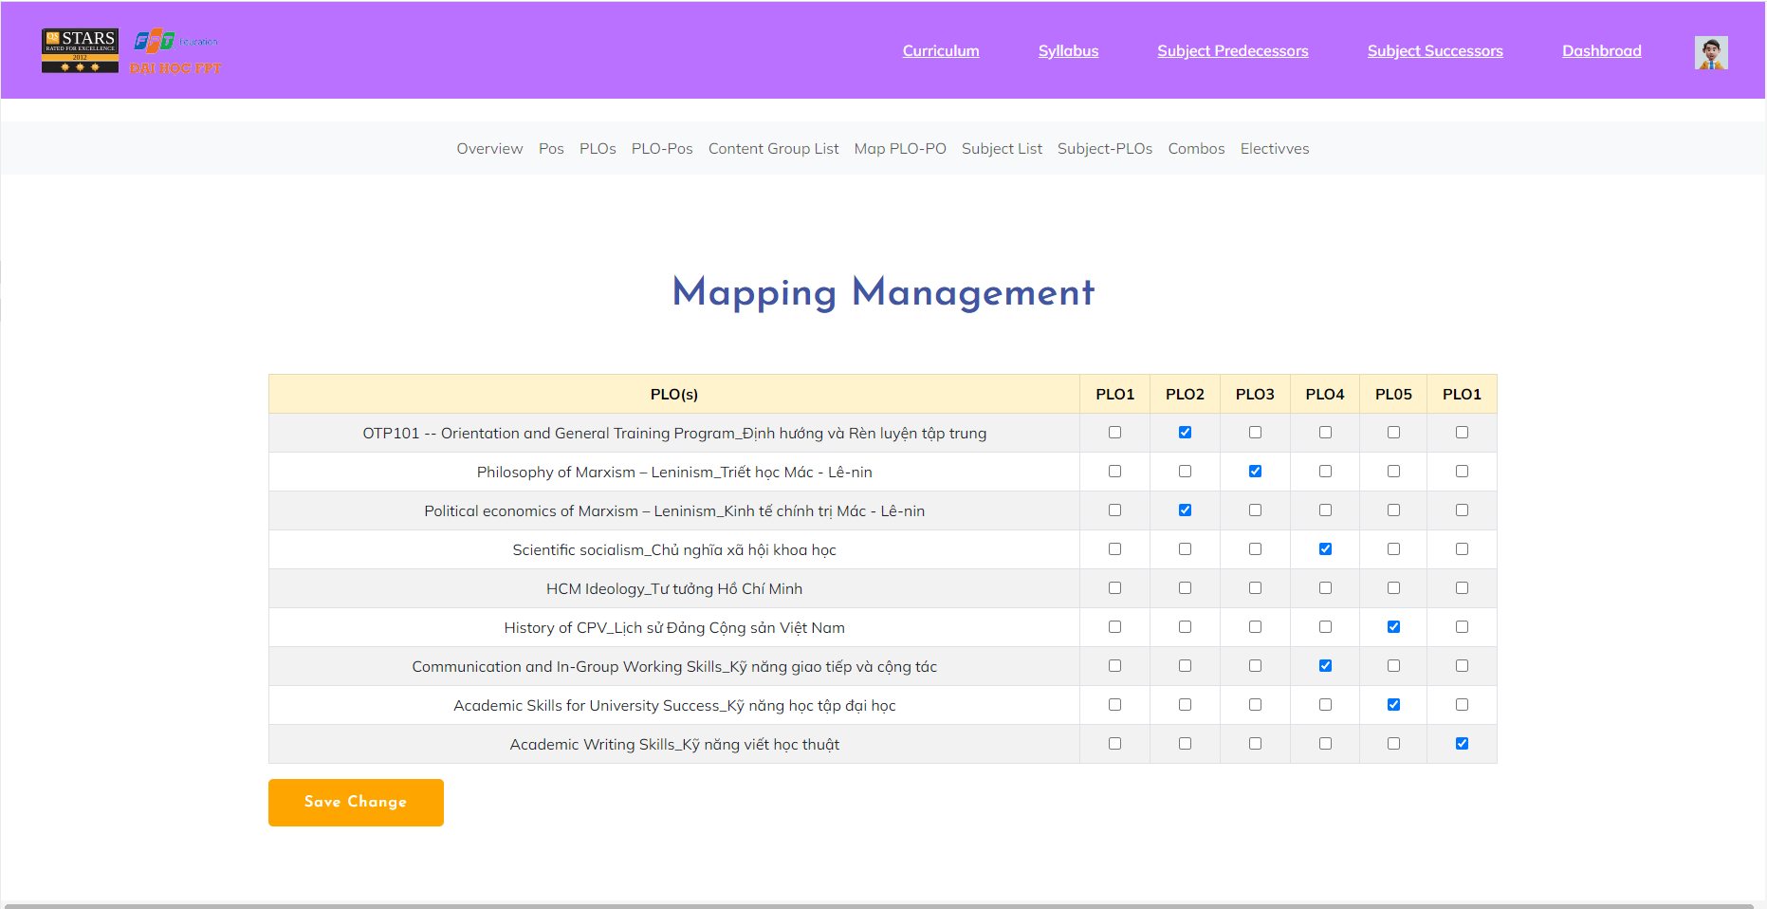
* **Functional Details**: PLOs are the intended outcomes or goals that students are expected to achieve by the end of a program, while subjects or courses are the individual units of study within that program.

1. **Curriculum Subject Details**

**f.1. Subject Details**

* **Function trigger**: This function is triggered when the admin logs in successfully and chooses 'Curriculum ' and chooses the function view of curriculum after choosing SubjectList and clicking Subject Name.
* **Function description**: The user can read Subject, Curriculum, Semester, No_Credit
* **Screen layout**:

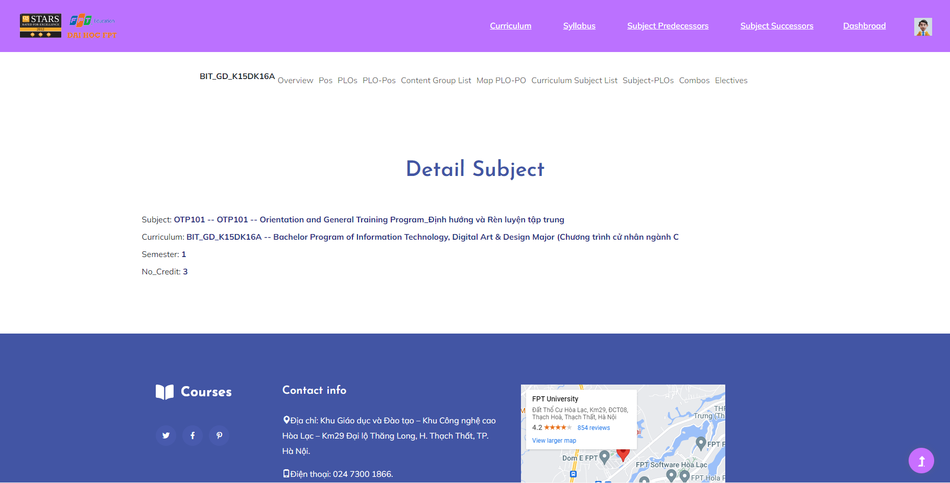

* **Functional Details**: The user can see the details of the subject.

**f.2** **Subject Edit**

* **Function trigger**: This function is triggered when the admin logs in successfully and chooses 'Curriculum ' and chooses the function view of curriculum after choosing SubjectList and clicking Function.
* **Function description**: The admin can edit Subject
* **Screen layout**: 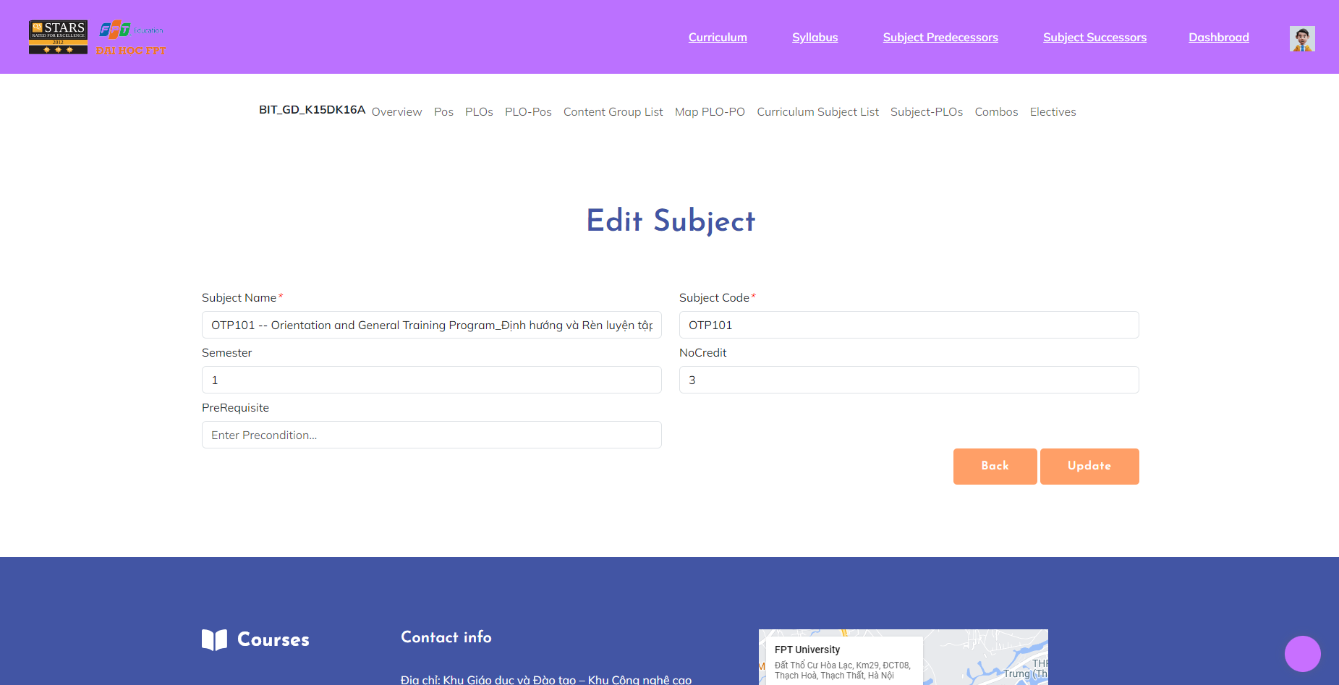
* **Functional Details**: The admin can update the subject.

1. **Subject Details**

**g.1. Subject Details**

* **Function trigger**: This function is triggered when the admin logs in successfully and chooses ‘Manage Subjects' and clicks Subject Name.
* **Function description**: The user can read Subject, Curriculum, Semester, No_Credit
* **Screen layout**: 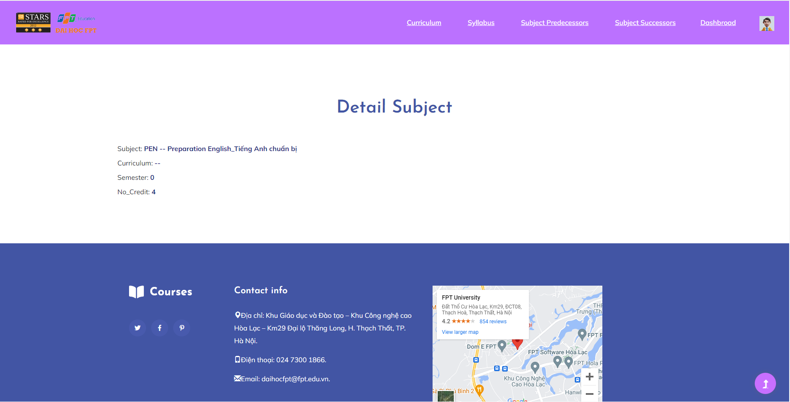
* **Functional Details**: The user can see the details of the subject.

**C. Curriculum Subjects**

1. **Subject Predecessors**

* **Function trigger**: When people visit the website, they can access this function when they select Subject Predecessors on the header.
* **Function description**: The syllabus list shows information about all the system's syllabuses and all the previous required subjects of each subject..
* **Screen layout**: simulated prototype of screen, below sample is for subject predecessors screen

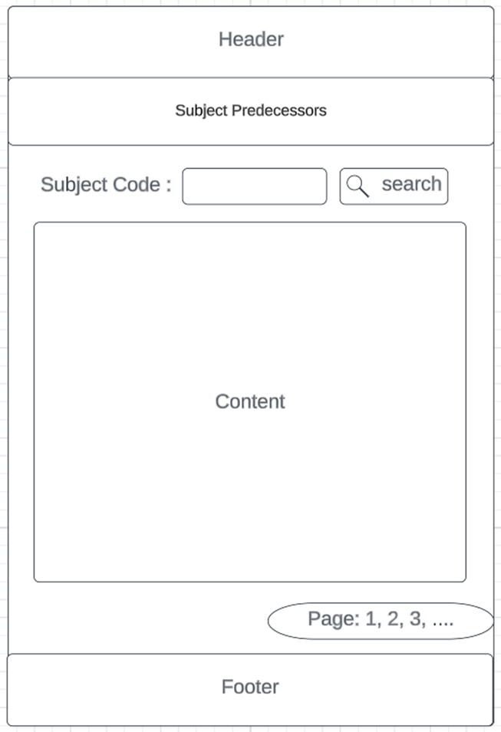

* **Functional Details**: Allows anyone accessing the website to view the list of textbooks and subject predecessors when clicking on the button to view the corresponding curriculum. Admins can access to edit and add syllabus when they select the button to do it

1. **Subject Successors**

* **Function trigger**: When people visit the website, they can access this function when they select Subject Successors the header
* **Function description**: The syllabus list shows information about all the system's syllabuses and all subjects learn after each subject.
* **Screen layout**: simulated prototype of screen, below sample is for subject successors screen

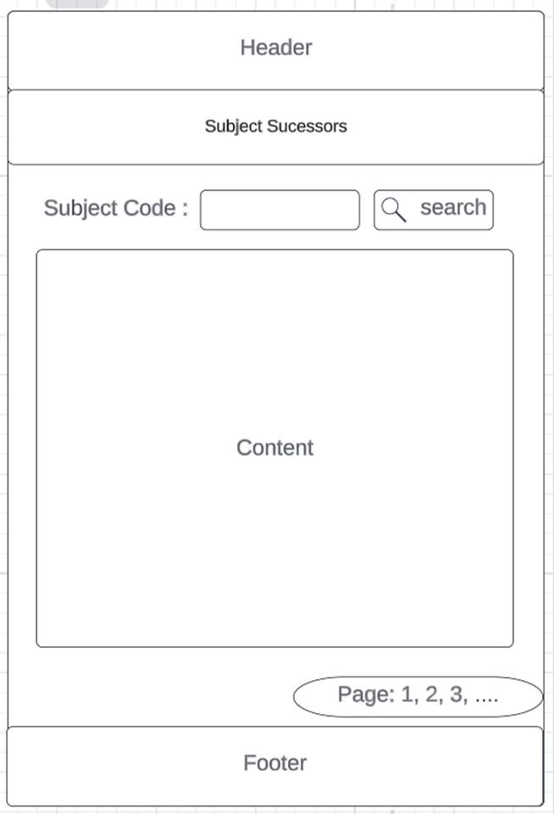

* **Functional Details**: Allows anyone accessing the website to view the list of textbooks and subject successors when clicking on the button to view the corresponding curriculum. Admins can access to edit and add syllabus when they select the button to do it

**3. Curriculums Details**

**A. PO Management**

1. **PO List**

* **Function trigger**: The function of the PO List is triggered when a user requests to view the list.
* **Function description**: The PO List function is responsible for providing users with a comprehensive list of PO specifically tailored for FLM. The function should display the PO in a structured and organised manner, allowing users to easily search, filter, and access the relevant outcomes. Users should be able to view detailed information about each Program Outcome and perform actions such as adding or modifying outcomes if they have the appropriate permissions.
* **Screen layout**:

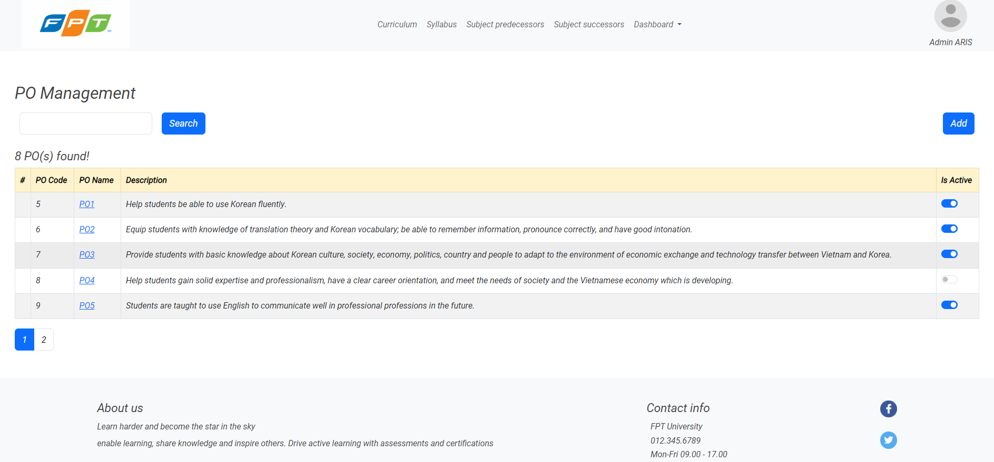

* **Functional Details**:

- Allow users to select multiple Program Outcomes from the list for bulk actions or operations.

- Implement access control and permission settings to ensure appropriate users can view and interact with the PO List.

1. **PO Details**

* **Function trigger**: The function of the PO Details is triggered when a user selects a specific PO from the PO List or requests to view the details of a Program Outcome in the FLM.
* **Function description**: The PO Details function provides users with in-depth information and comprehensive details about a specific PO within the FLM. It allows users to access information such as learning objectives, assessment methods, associated learning materials, and any other relevant details pertaining to the selected PO. Users should be able to view, edit, and manage the details of the POe if they have the appropriate permissions.
* **Screen layout**:

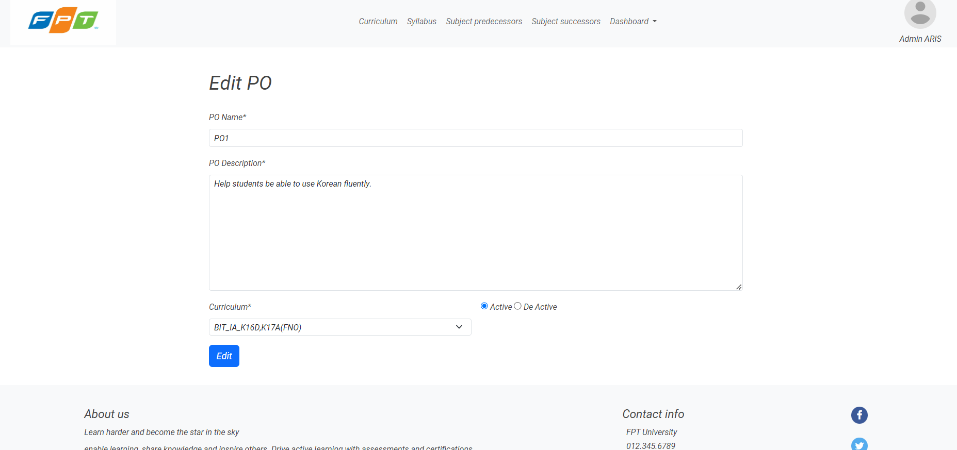

* **Functional Details**:

- Enable users to edit and update the details of a Program Outcome, if they have the appropriate permissions.

- Provide options to add or remove learning objectives, assessment methods, or associated learning materials for a Program Outcome.

- Implement validation checks to ensure the accuracy and completeness of the entered data or modifications.

1. **PO Import**

* **Function trigger**: The function of PO Import is triggered when a user initiates the import process for PO in the FLM. This can be triggered manually by the user or through an automated import routine.
* **Function description**: The PO Import function allows users to import PO in bulk into the FLM. This function simplifies the process of adding multiple at once, saving time and effort. Users should be able to upload a file Excel containing the PO data, and the system should validate and process the file to populate the PO database.
* **Screen layout**:

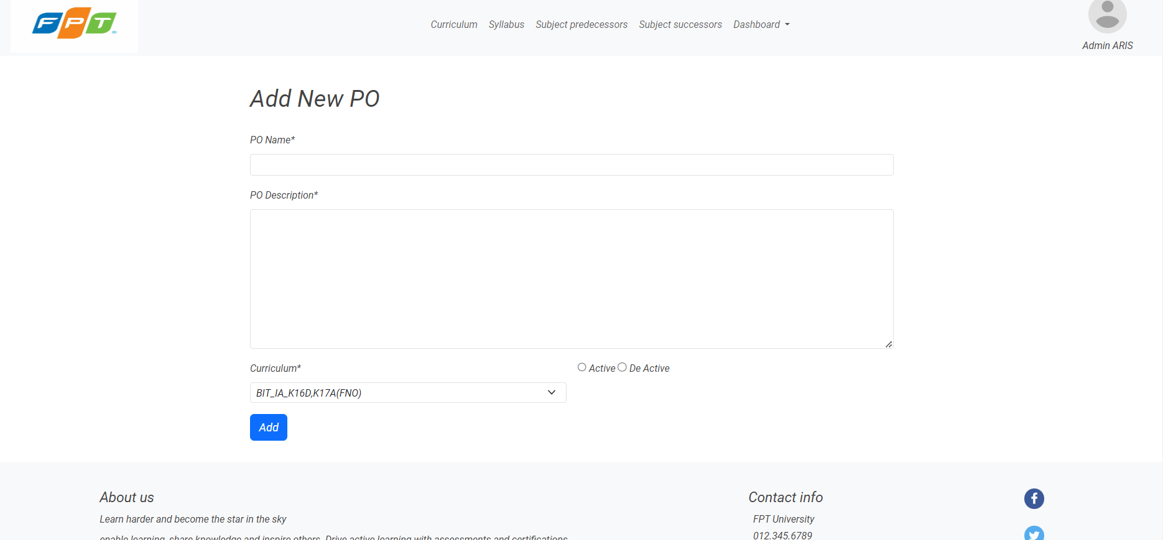

* **Functional Details**:
* Support various file formats commonly used for data interchange, such as CSV, Excel, or XML.
* Validate the format, structure, and integrity of the imported data to prevent errors during the import process.
* Implement mechanisms to handle large datasets and optimize the import performance.

**B. PLO Management**

1. **PLO List**

* **Function trigger**: This function is activated when the administrator successfully logs in and selects the Curriculum page and selects Name, then selects PLO mode on the header.
* **Function description**: The PLO List function is responsible for providing users with a comprehensive list of PLO specifically tailored for FLM. The function should display the PLO in a structured and organised manner, allowing users to easily search.
* **Screen layout**: 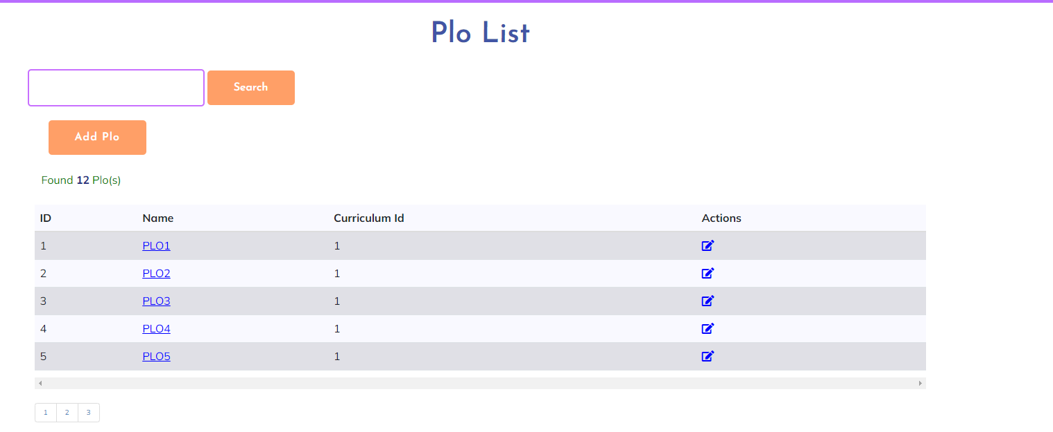
* **Functional Details**: - Allow users to select multiple Program Outcomes from the list for bulk actions or operations.
* - Implement access control and permission settings to ensure appropriate users can view and interact with the PLO List.

1. **PLO Details**

* **Function trigger**: The function of the PLO Details is triggered when a user selects a specific plo from the PLO List in the FLM.
* **Function description**: The PLO Details function provides users with in-depth information and comprehensive details about a specific PLO within the FLM. Admin should be able to view, edit, and manage the details of the PLO .
* **Screen layout**:
* 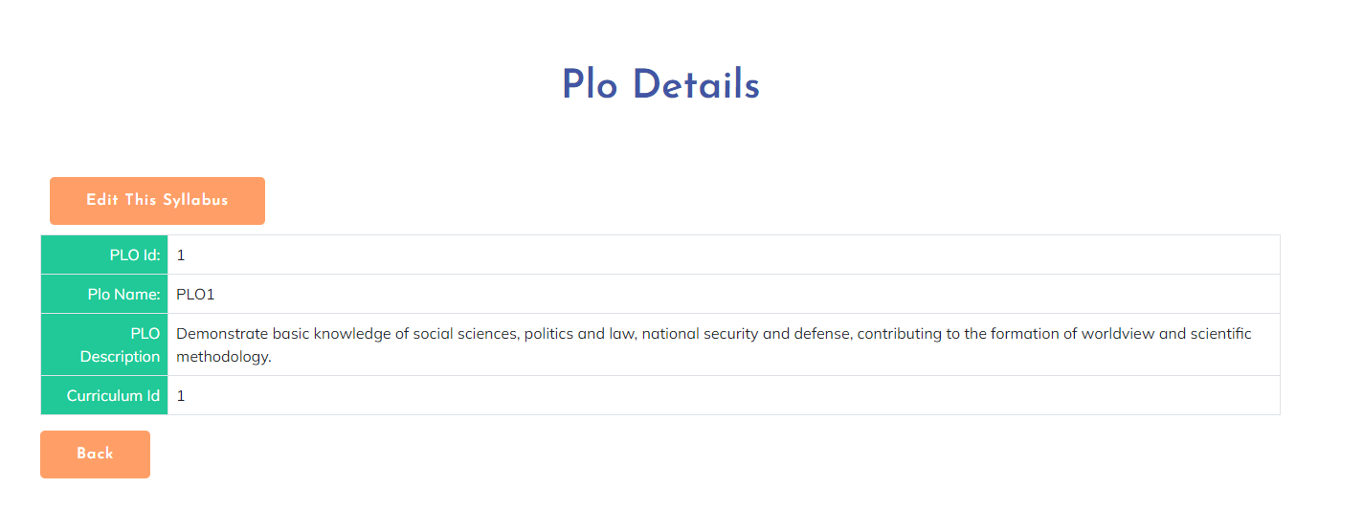
* **Functional Details**:

- Provide options to add or remove learning objectives, assessment methods, or associated learning materials for a Program Outcome.

- Implement validation checks to ensure the accuracy and completeness of the entered data or modifications.

1. **PLO Import**

* **Function trigger**:
* **Function description**:
* **Screen layout**:
* **Functional Details**:

1. **PLO-PO Mapping**

* **Function trigger**: The function of the PLO PO Mappingis triggered when a user selects a specific clo from the PLO Po Mapping in the FLM.
* **Function description**: The admin can edit the PLO corresponding to the subjects
* **Screen layout**: 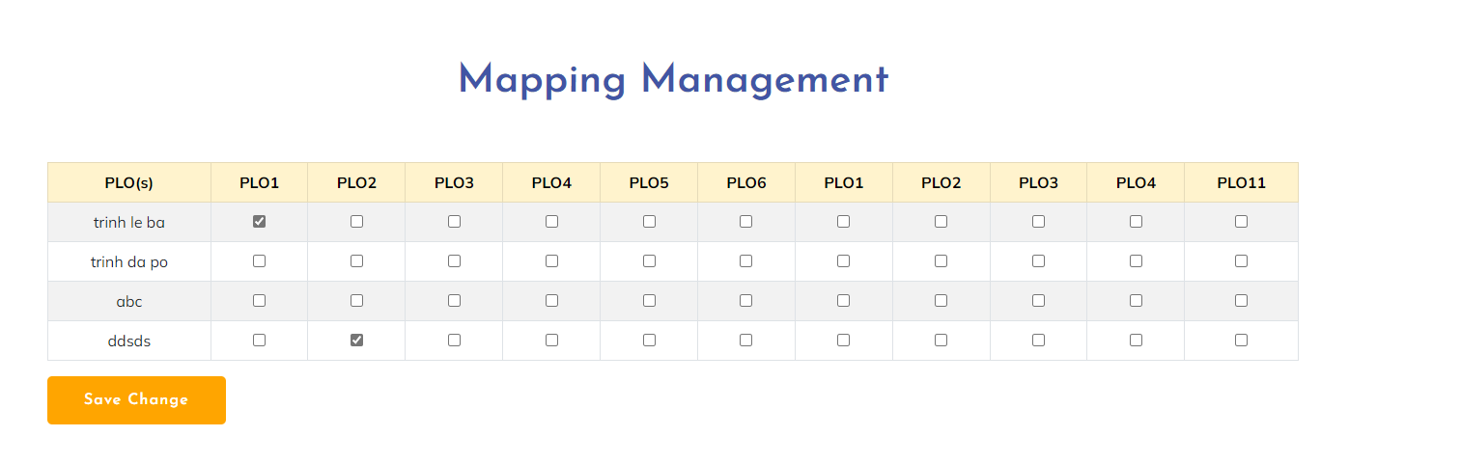
* **Functional Details**: PLOs are the intended outcomes or goals that students are expected to achieve by the end of a program, while subjects or courses are the individual units of study within that program.

**C. Subject Groups**

1. **Combo List**

* **Function trigger**: This function is triggered when user from curriculum overview screen, click on Combo list
* **Function description**: This screen displays the elective list, sorts, searches, filters the list
* **Screen layout**: mock-up prototype of the screen, sample below is for the Combo list screen

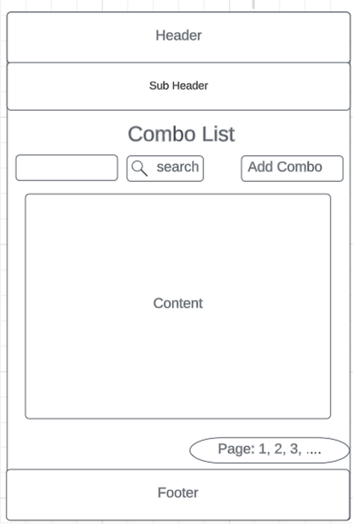

* **Functional Details**: This screen displays the list of all Combo. Users can search, filter, sort the list as they want. System admin can edit and add new Combo.

1. **Combo Details**

* **Function trigger**: This function is triggered when user from Combo list screen, choose view button of corresponding combo they want to see
* **Function description**: This screen displays detailed information of corresponding combo
* **Screen layout**: mock-up prototype of the screen, sample below is for the combo details screen

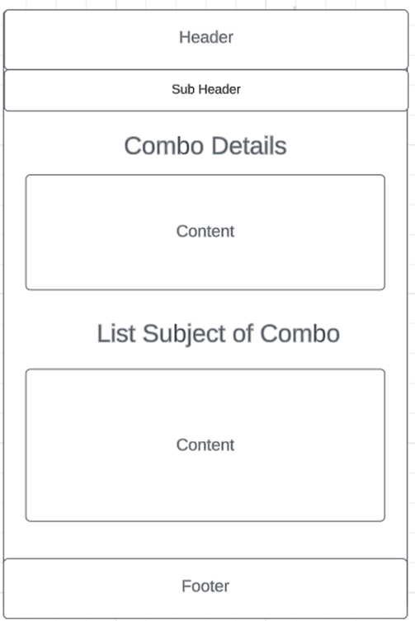

* **Functional Details**: This screen allows users to view detailed information of corresponding combo

1. **Content Group List**

* **Function trigger**: This function is triggered when user from curriculum overview screen, click on content group list
* **Function description**: This screen displays the content group list, sorts, searches, filters the list
* **Screen layout**: mock-up prototype of the screen, sample below is for the content group list screen

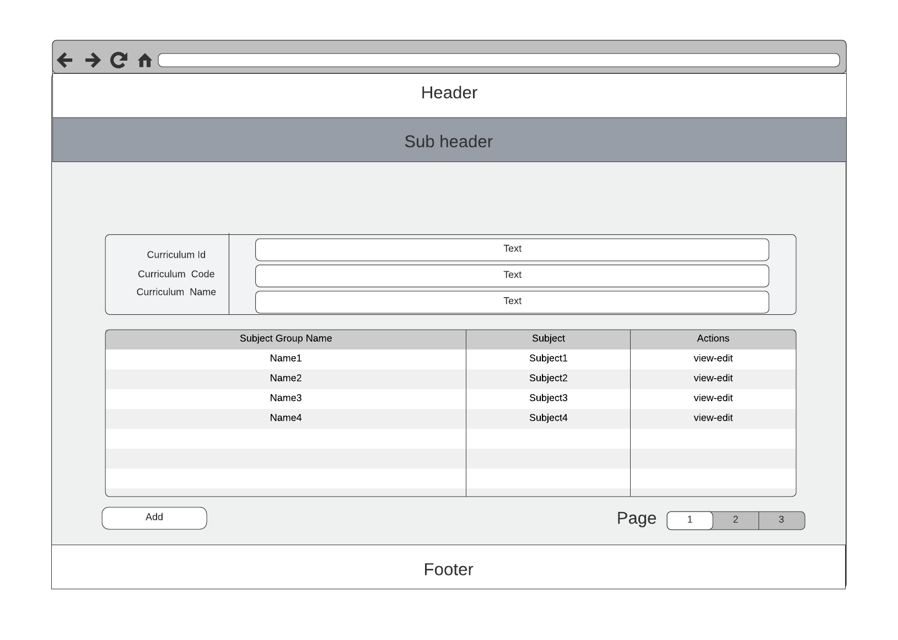

* **Functional Details**: This screen displays the list of all content groups. Users can search, filter, sort the list as they want. System admin can edit and add new content groups.

1. **Content Group Details**

* **Function trigger**: This function is triggered when user from content group list screen, choose view button of corresponding content group they want to see
* **Function description**: This screen displays detailed information of corresponding content group
* **Screen layout**: mock-up prototype of the screen, sample below is for the content group details screen

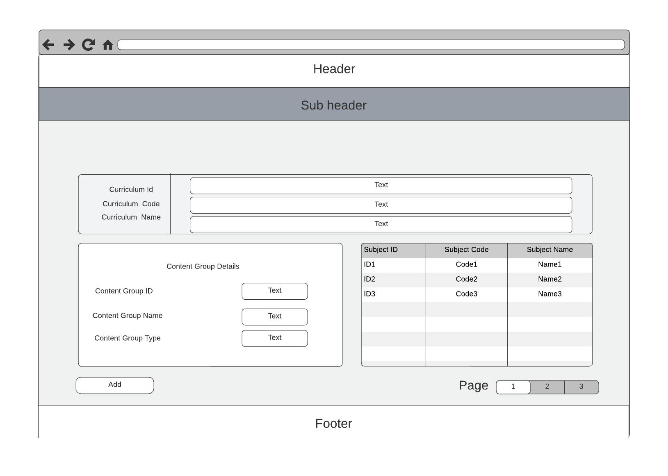

* **Functional Details**: This screen allows users to view detailed information of corresponding content group

1. **Elective List**

* **Function trigger**: This function is triggered when user from curriculum overview screen, click on elective list
* **Function description**: This screen displays the elective list, sorts, searches, filters the list
* **Screen layout**: mock-up prototype of the screen, sample below is for the elective list screen

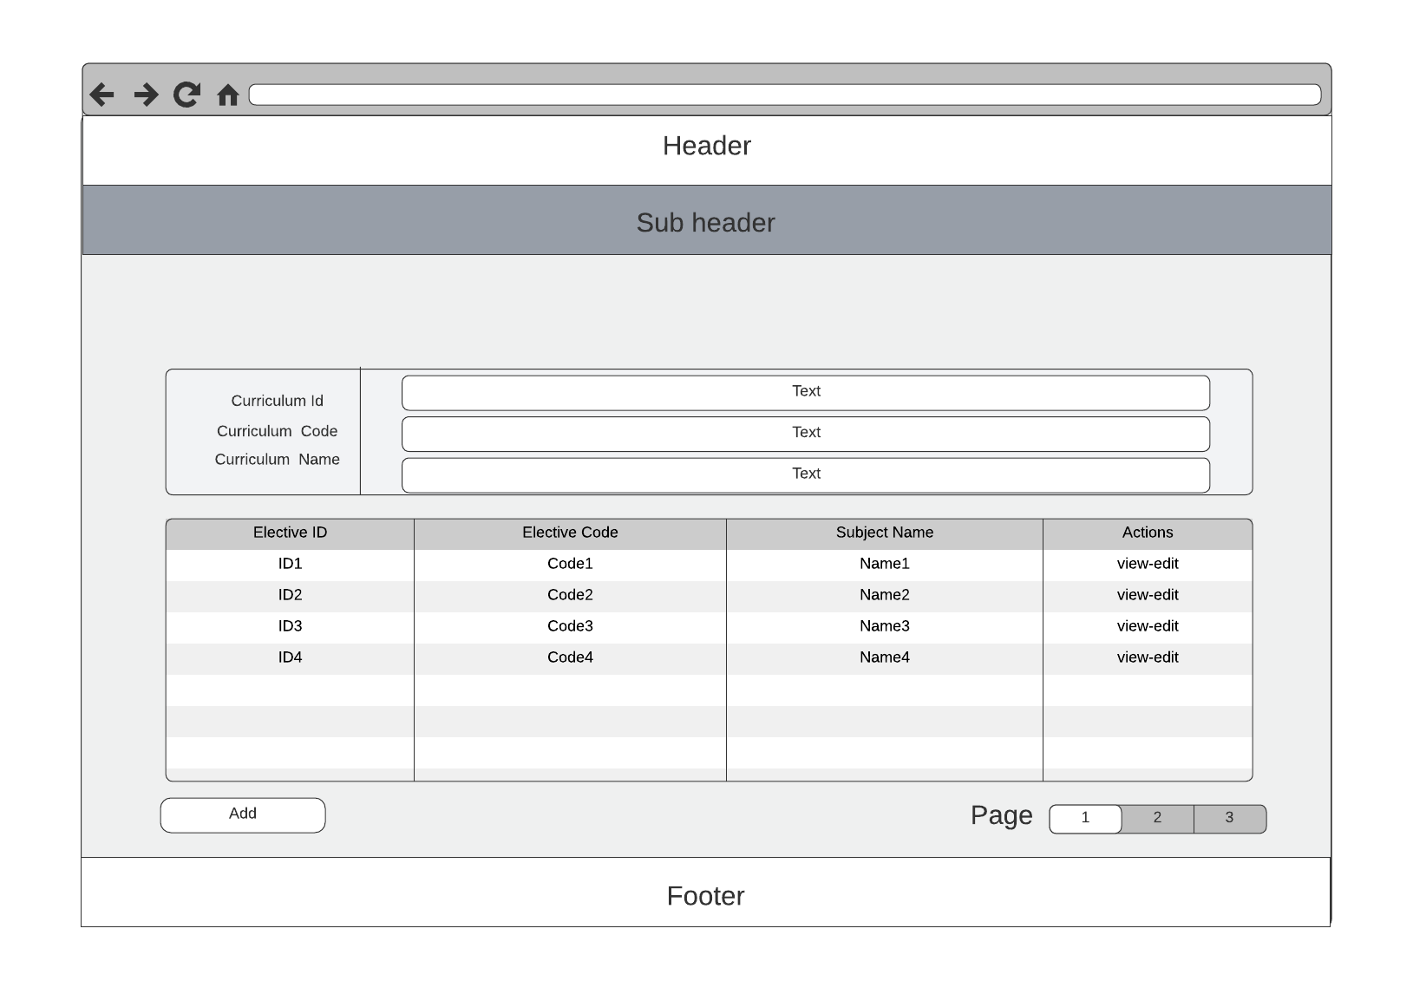

* **Functional Details**: This screen displays the list of all electives. Users can search, filter, sort the list as they want. System admin can edit and add new electives.

1. **Elective Details**

* **Function trigger**: This function is triggered when user from elective list choose to edit corresponding elective
* **Function description**: This screen contains all field of information in detail of elective
* **Screen layout**: mock-up prototype of the screen, sample below is for the elective detail screen

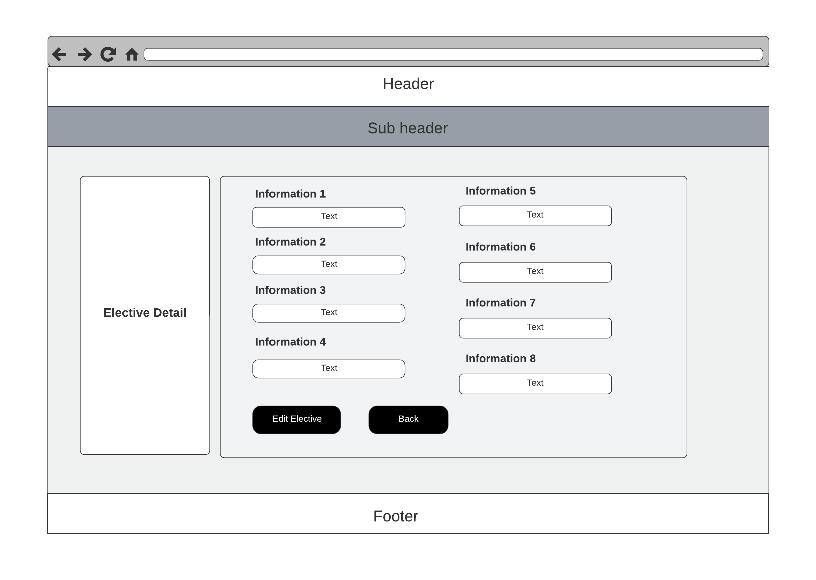

* **Functional Details**: This screen allows users to view detailed information of

1. **Combo Add**

* **Function trigger**: This function is triggered when user from Combo list screen, choose view button combo add
* **Function description**: This screen shows the box to fill in the information of the new combo
* **Screen layout**: mock-up prototype of the screen, sample below is for the new combo screen

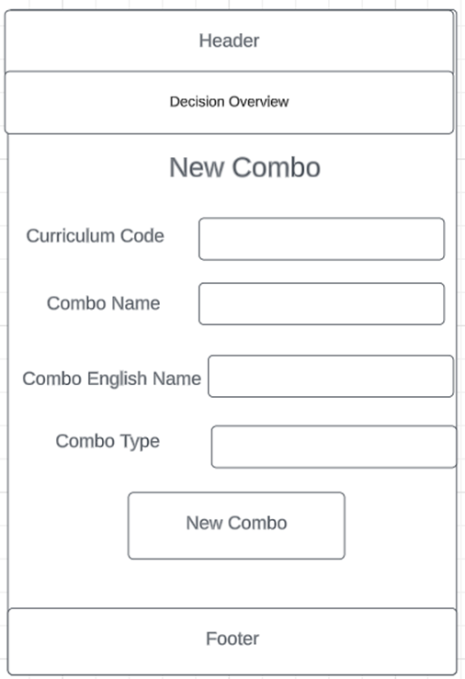

* **Functional Details**: This screen allows the manager to add a new combo to the combo list

**4. Syllabus Management**

**A. Syllabus Management**

1. **Syllabus List**

* **Function trigger**: This screen triggers when user click on Syllabus on the header of the webpage
* **Function description**: This screen displays all the syllabus of the application system. It consists of many actions with a syllabus list consisting of sort, pagination, search, filter…
* **Screen layout**: mock-up prototype of the screen, sample below is for the syllabus list screen

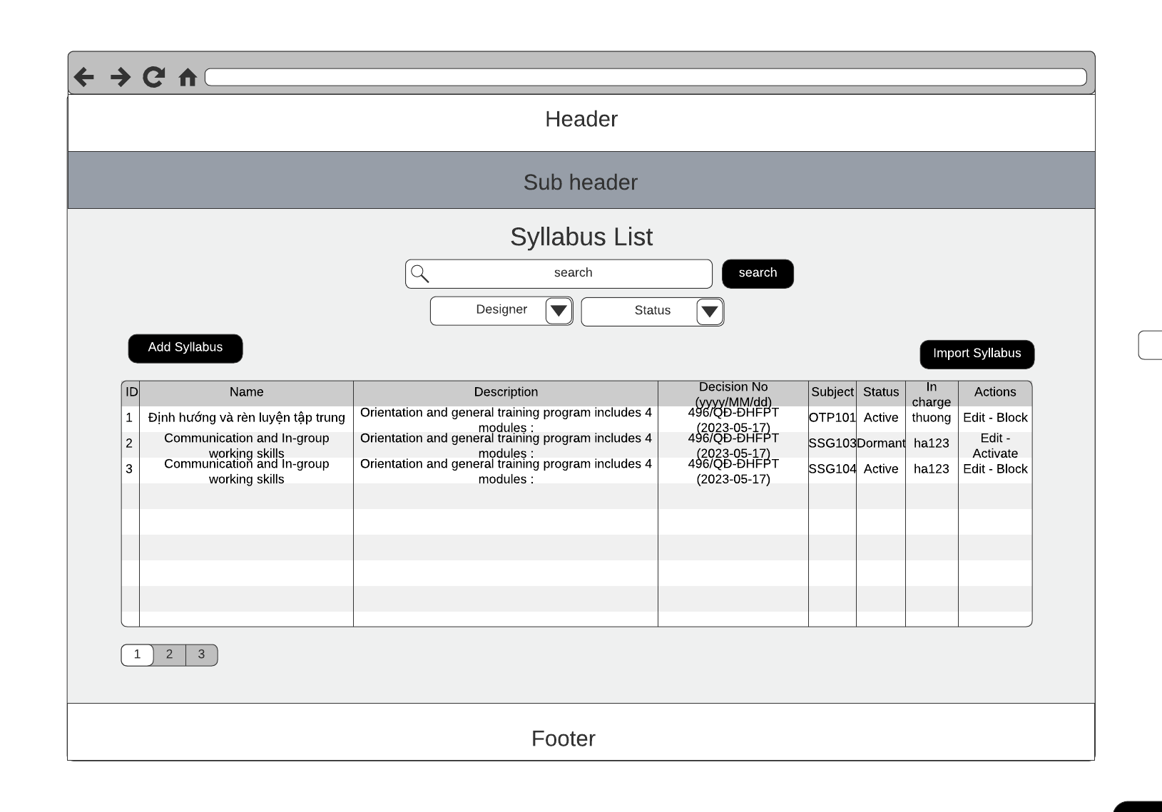

* **Functional Details**: This screen contains a variety of actions on the syllabus list (search, sort, paging, filter) which allows users to view and manage syllabus in the application system. For authorised roles which are admin and staff, they can manage all the syllabus, designer of the syllabus and have an integrated path to some other functions such as add, edit, activate, deactivate while the rest of the roles can only view the syllabus with active state.

1. **New Syllabus**

* **Function trigger**: The function should be triggered when a user accesses the FPT education learning material system or when there is a need to update or modify the existing syllabus.
* **Function description**: The function allows administrators to input the necessary details of a new syllabus for FPT Education Learning Material, including the course name, course code, description, modules, and topics. This information serves as the foundation for organizing and structuring the syllabus content.
* **Screen layout**:

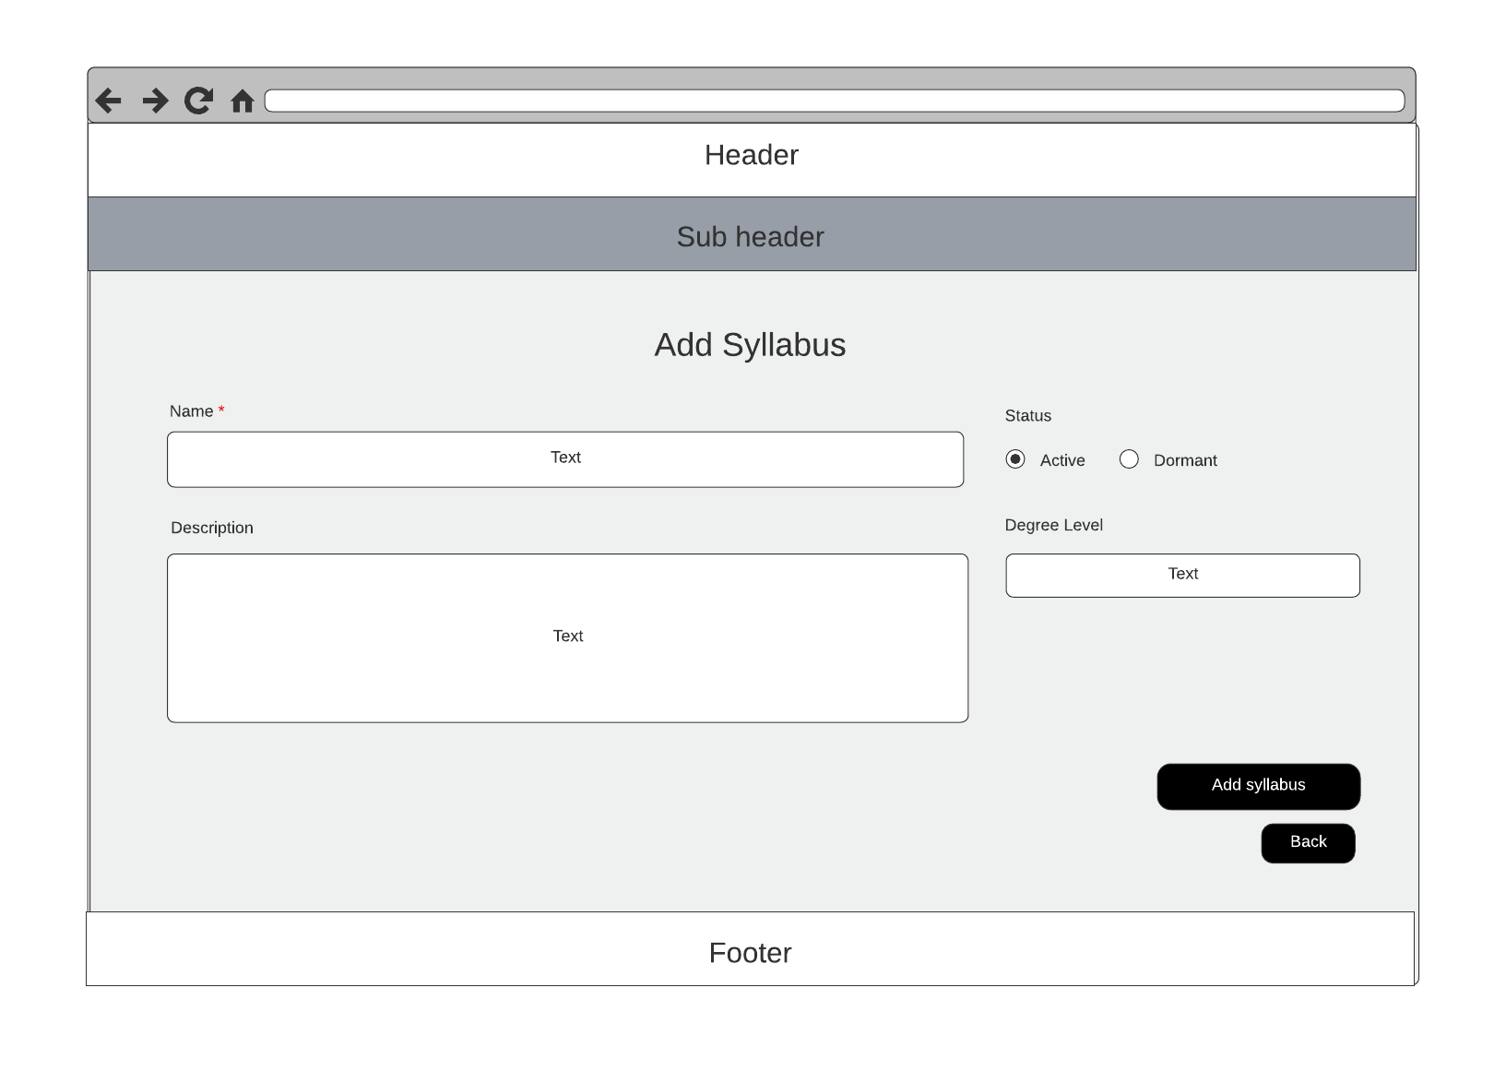

* **Functional Details**: enables administrators to create a new syllabus for a specific course. It provides a comprehensive framework for organizing and delivering educational content to students. The function allows administrators to input syllabus details, define learning objectives, structure modules and topics, specify assessment criteria, and integrate learning resources. This function plays a critical role in designing and implementing an effective curriculum.

Input Syllabus Details: Administrators are provided with input fields to enter essential information about the syllabus, such as the course name, course code, description, and other relevant metadata. This information provides a clear overview of the course and its objectives.

1. **Syllabus Import**

* **Function trigger**: The Syllabus Import function is triggered when administrators initiate the process of importing a syllabus into the system.
* **Function description**: The Syllabus Import function allows administrators to import syllabus data from external sources into the system. It enables administrators to efficiently populate the system with pre-existing syllabi, saving time and effort in manual data entry.
* **Screen layout**:

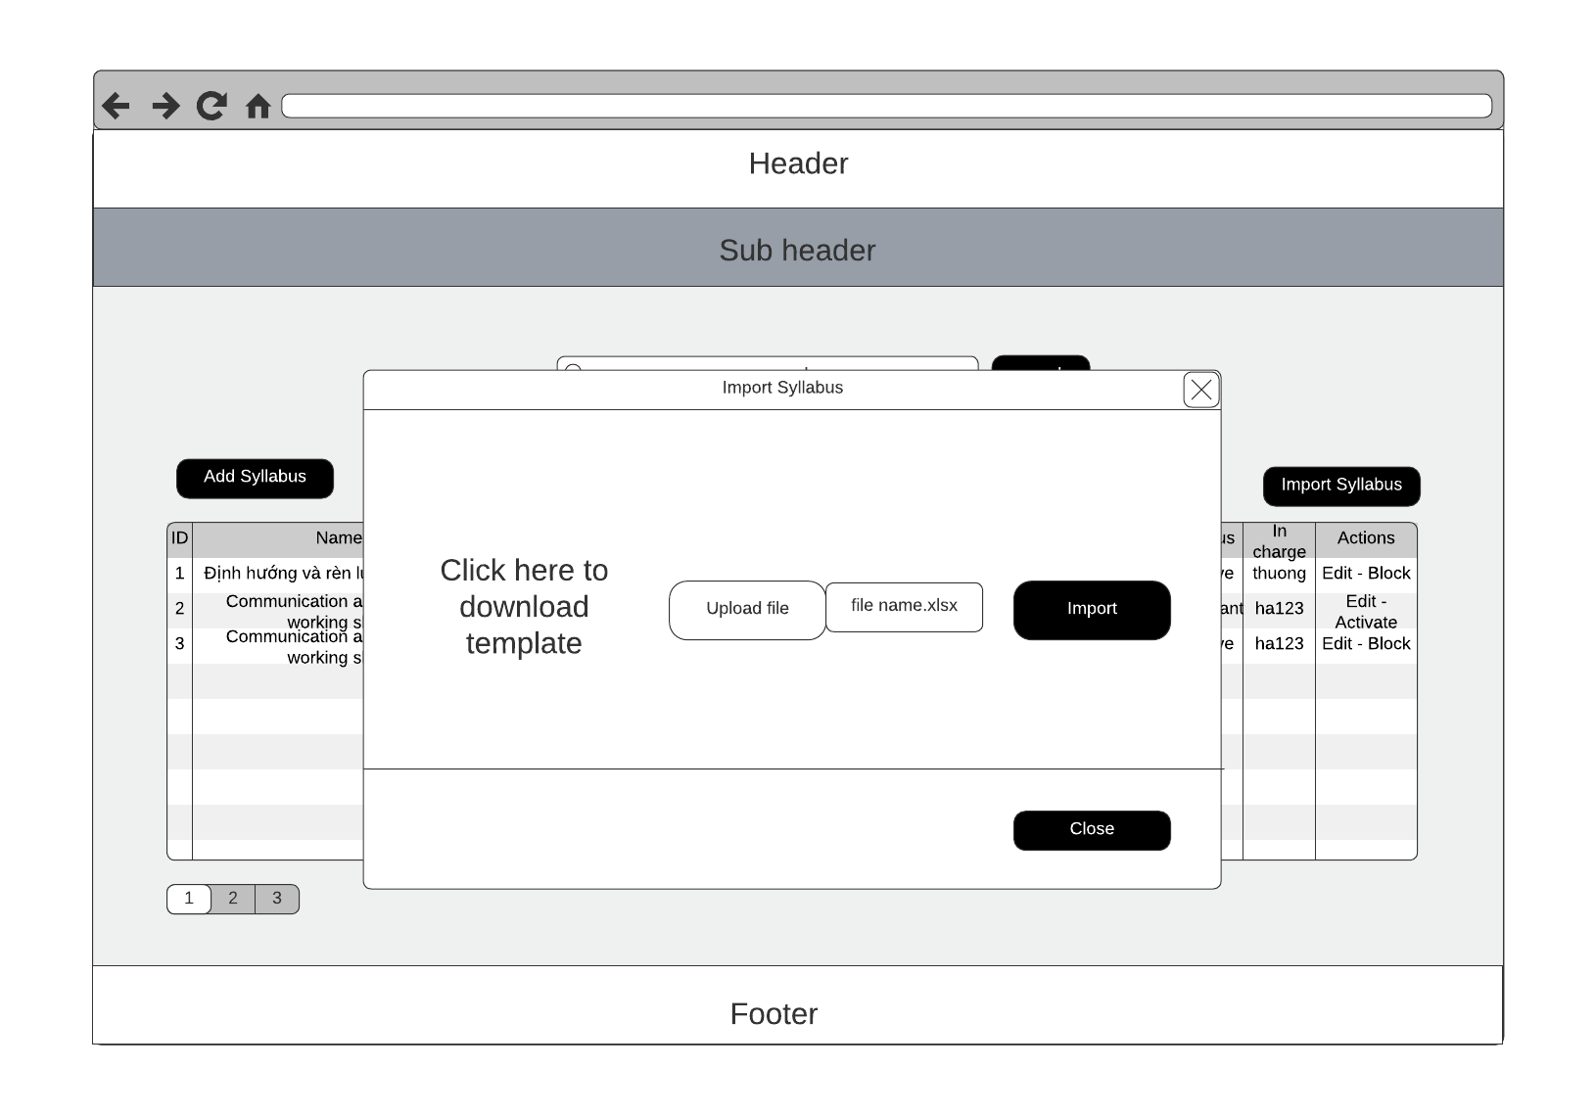

* **Functional Details**:

Import Source Selection: Provide options for administrators to choose the import source, such as a file upload, LMS integration, or external database connection.Support common file formats for import, such as CSV, Excel, or compatible LMS formats.

Data Mapping and Validation: Allow administrators to map the data fields from the import source to the corresponding fields in the system.Validate the imported data for consistency, accuracy, and integrity.

Import Options: Allow administrators to select specific modules or topics to import from the source, providing flexibility in importing only relevant sections. Provide options to exclude certain sections or elements from the import if desired.

1. **Syllabus Overview**

* **Function trigger**: From the Syllabus List page, the user clicks on the required syllabus name, the Syllabus Overview screen will appear
* **Function description**: This screen presents detailed information about the syllabus including basic information such as id, name, description along with general information about the subject, decision.
* **Screen layout**: mock-up prototype of the screen, sample below is for the syllabus overview screen

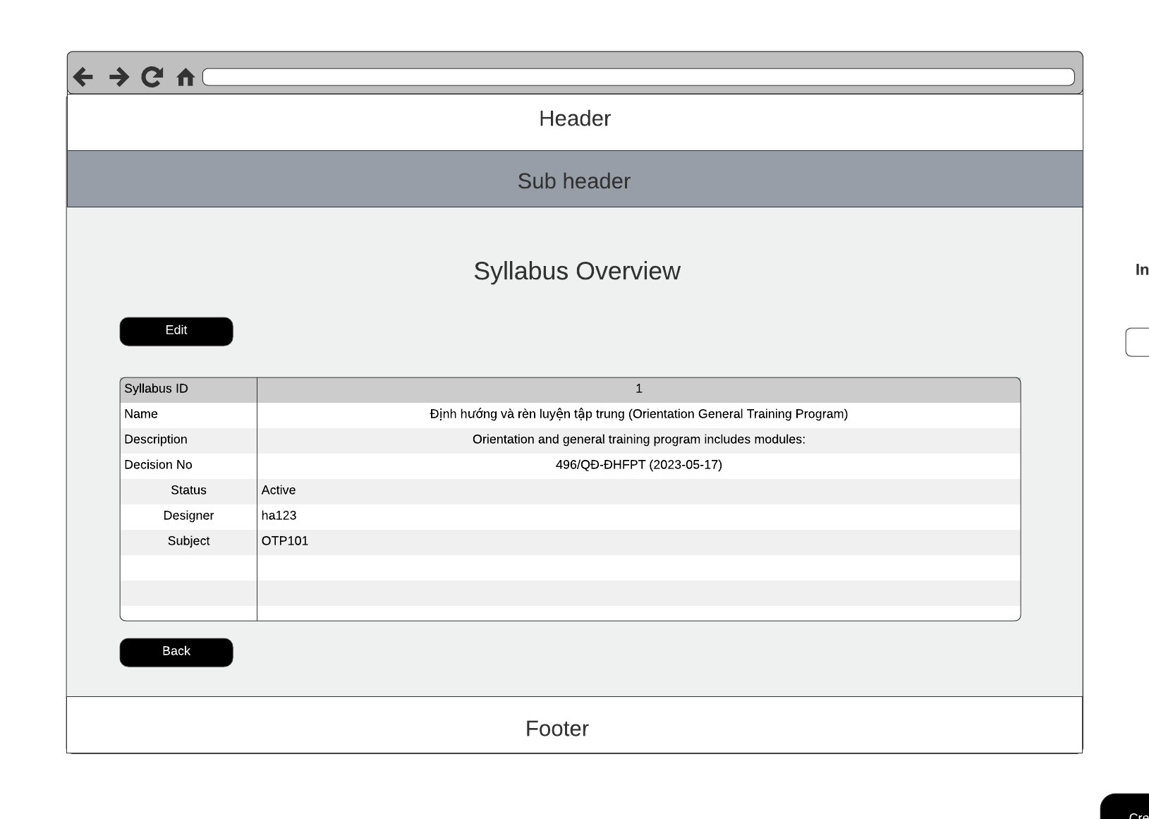

* **Functional Details**: The screen allows the user to view detailed information about the syllabus

1. **Syllabus Edit**

* **Function trigger**: The Syllabus Edit function is triggered when administrators initiate the process of editing an existing syllabus in the FLM system.
* **Function description**: The Syllabus Edit function allows administrators to modify and update the content, structure, and details of an existing syllabus within the FLM system. It provides administrators with the necessary tools and functionalities to make changes to the syllabus, ensuring it remains up-to-date and aligned with the evolving curriculum requirements.
* **Screen layout**:

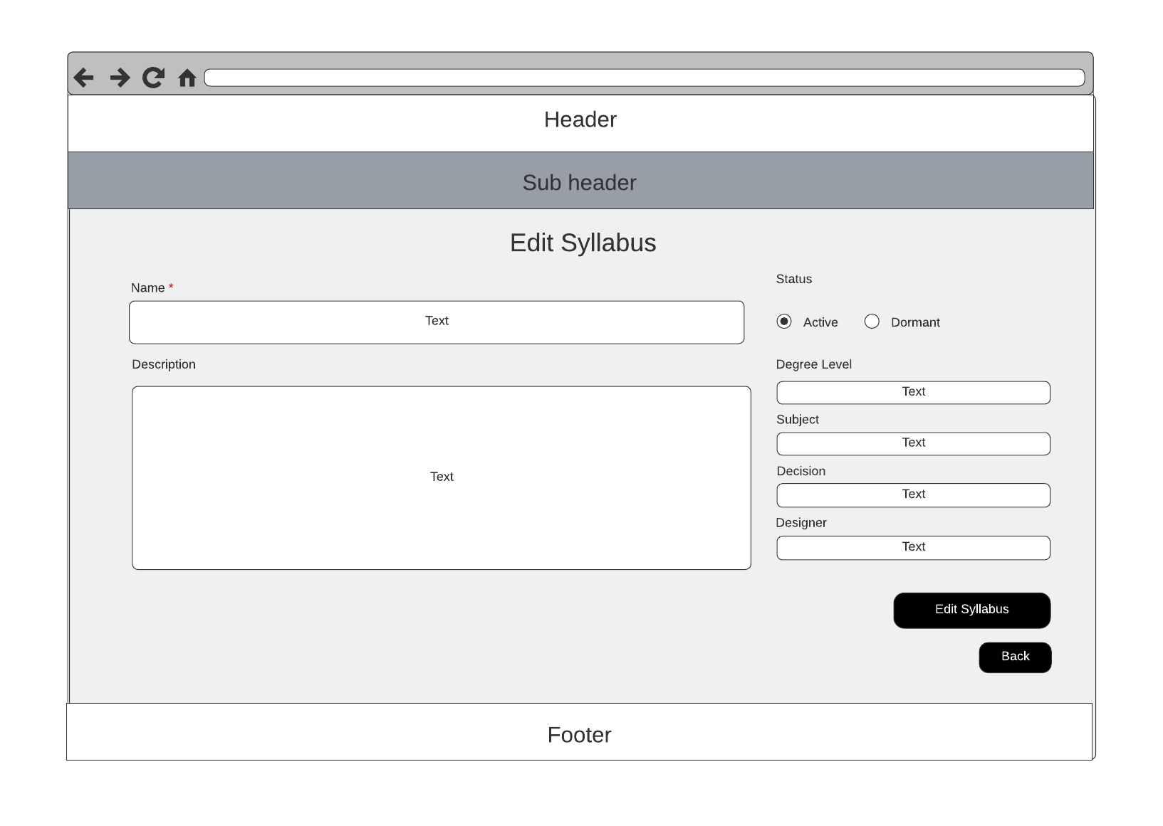

* **Functional Details**:

Syllabus Overview: Display the current details of the syllabus, such as course name, course code, description, and metadata. Enable administrators to modify or update these details as necessary.

Modules and Topics: Present the existing modules and topics in a structured format. Allow administrators to add, remove, or reorganise modules and topics within the syllabus. Provide drag-and-drop functionality or other intuitive mechanisms for easy rearrangement.

**B. CLO Management**

1. **CLO List**

* **Function trigger**: This function is activated when the administrator successfully logs in and selects the Course page and selects Name, then selects CLOs mode on the header.
* **Function description**: The CLO List function is responsible for providing users with a comprehensive list of CLO specifically tailored for FLM. The function should display the PO in a structured and organised manner, allowing users to easily search, filter, and access the relevant outcomes.
* **Screen layout**: 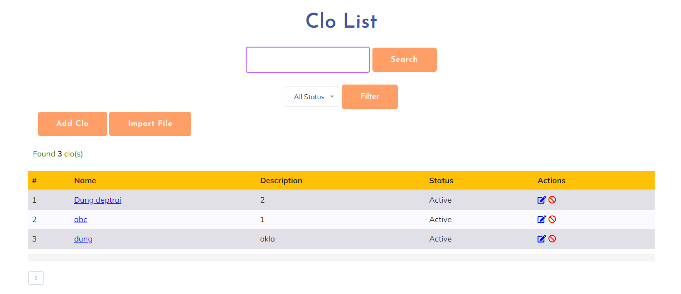
* **Functional Details**:

- Allow users to select multiple CLO from the list for bulk actions or operations.

- Implement access control and permission settings to ensure appropriate users can view and interact with the CLO List.

1. **CLO Details**

* **Function trigger**: The function of the CLO Details is triggered when a user selects a specific clo from the CLO List in the FLM.
* **Function description**: The CLO Details function provides users with in-depth information and comprehensive details about a specific CLO within the FLM. Admin should be able to view, edit, and manage the details of the CLO.
* **Screen layout**: 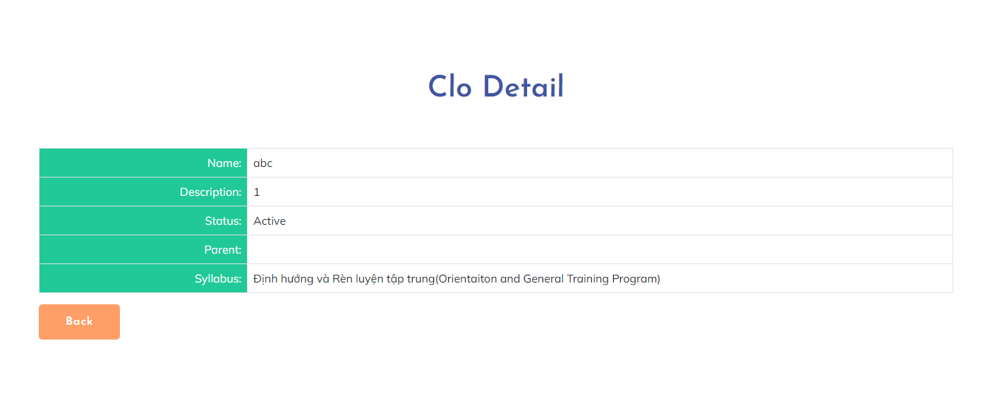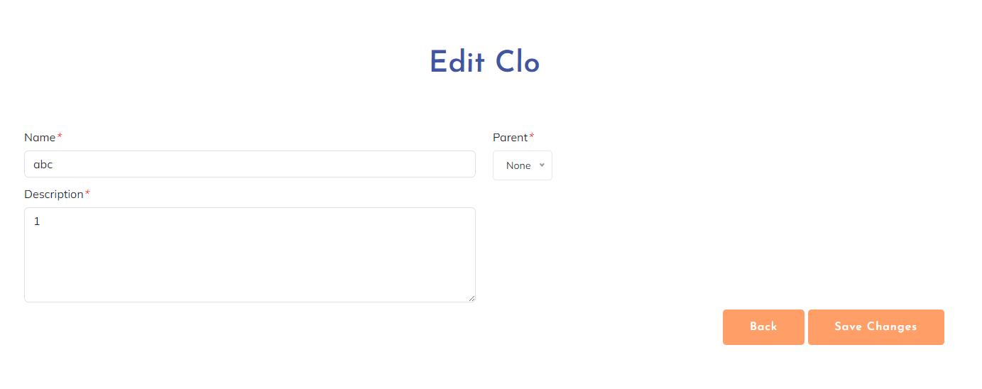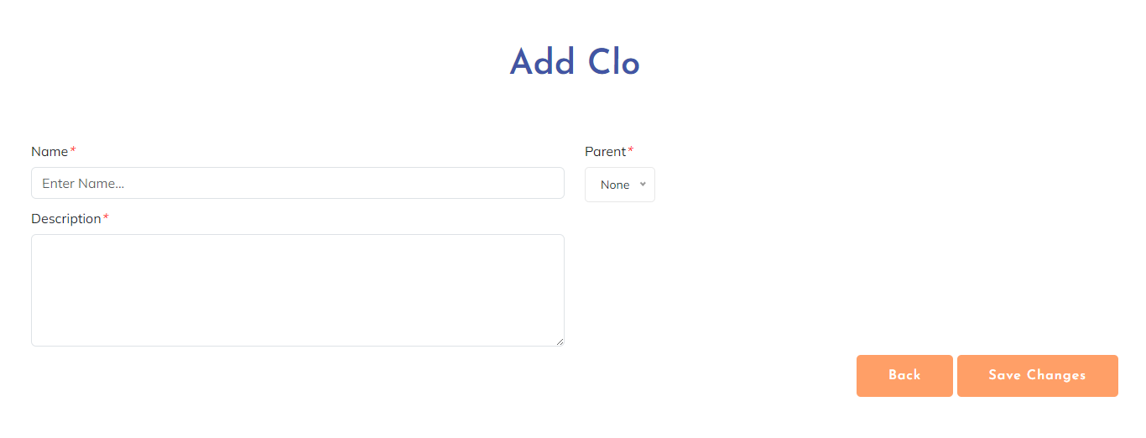
* **Functional Details**:

- Provide options to add or remove learning objectives, assessment methods, or associated learning materials for a Program Outcome.

- Implement validation checks to ensure the accuracy and completeness of the entered data or modifications.

1. **CLO Import**

* **Function trigger**: The function of CLO Import is triggered when a user initiates the import process for CLO in the FLM. This can be triggered manually by the user or through an automated import routine.
* **Function description**: The CLO Import function allows users to import CLO in bulk into the FLM. This function simplifies the process of adding multiple at once, saving time and effort. Users should be able to upload a file Excel containing the CLO data, and the system should validate and process the file to populate the CLO database.
* **Screen layout**: 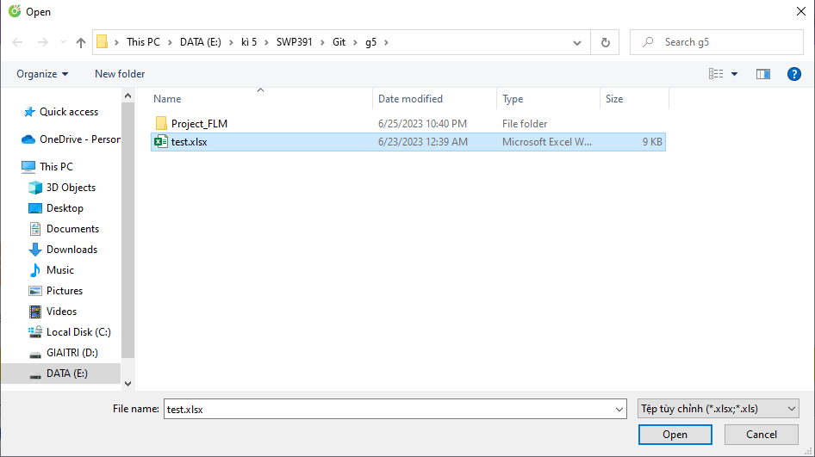
* 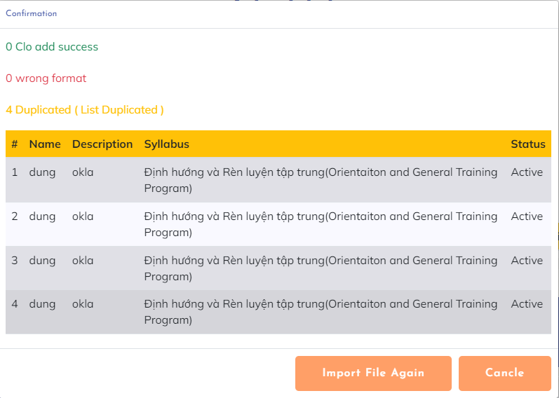
* **Functional Details**:
* Support various file formats commonly used for data interchange, such as Excel, or XML.
* Validate the format, structure, and integrity of the imported data to prevent errors during the import process.
* Implement mechanisms to handle large datasets and optimise the import performance.

1. **CLO-PLO Mapping**

* **Function trigger**:
* **Function description**:
* **Screen layout**:
* **Functional Details**:

**D. Training Schedule**

1. **Session List**

* **Function trigger**: This function is activated when the administrator successfully logs in and selects the Syllabus page and selects Name course, then selects Session mode on the header.
* **Function description**: The Session List function is responsible for providing users with a comprehensive list of Session specifically tailored for FLM. The function should display the Session in a structured and organised manner, allowing users to easily search, filter, and access the relevant outcomes.
* **Screen layout**:
* 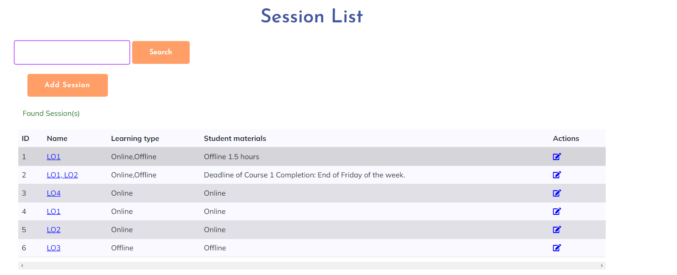
* **Functional Details**: - Allow users to select multiple Session from the list for bulk actions or operations.
* - Implement access control and permission settings to ensure appropriate users can view and interact with the Session List.

1. **Session Details**

* **Function trigger**: The function of the Session Details is triggered when a user selects a specific clo from the Session List in the FLM.
* **Function description**: The Session Details function provides users with in-depth information and comprehensive details about a specific Session within the FLM. Admin should be able to view, edit, and manage the details of the Session .
* **Screen layout**: 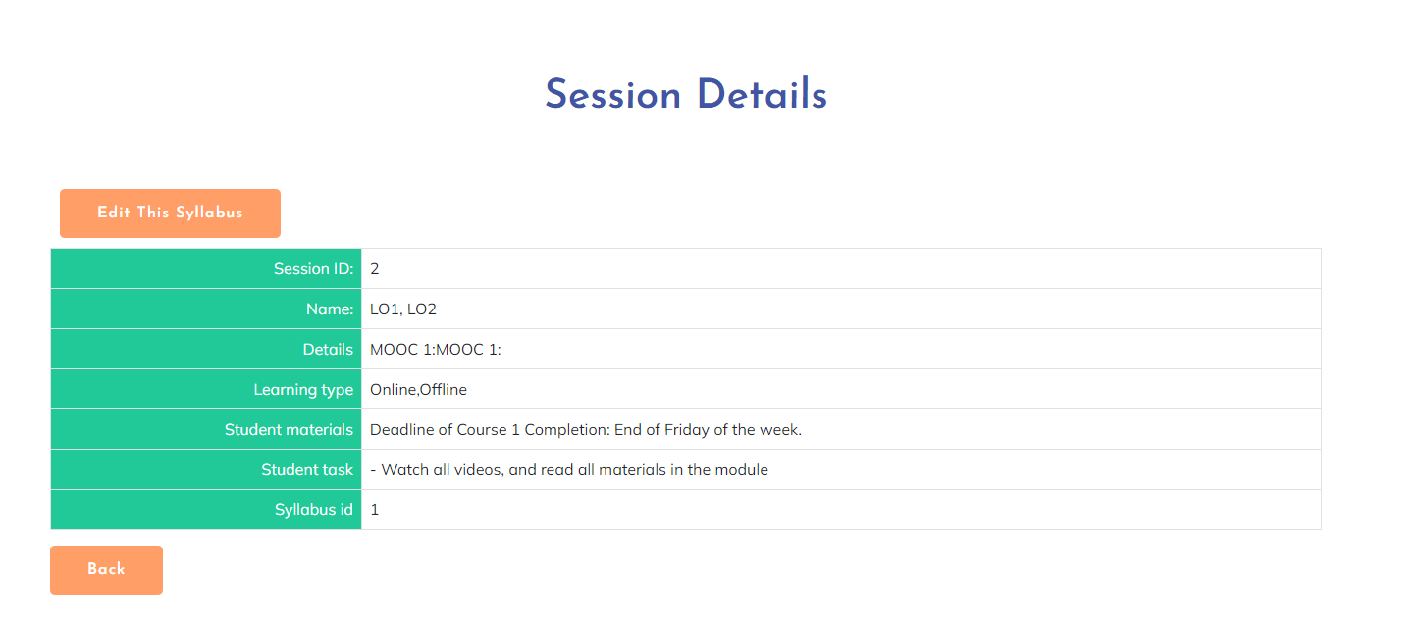
* **Functional Details**: Provide options to add or remove learning objectives, assessment methods, or associated learning materials for a Program Outcome.
* - Implement validation checks to ensure the accuracy and completeness of the entered data or modifications.

1. **Session Import**

* **Function trigger**: The function of Session Import is triggered when a user initiates the import process for Session in the FLM. This can be triggered manually by the user or through an automated import routine.
* **Function description**: The Session Import function allows users to import Session in bulk into the FLM. This function simplifies the process of adding multiple at once, saving time and effort. Users should be able to upload a file Excel containing the Session data, and the system should validate and process the file to populate the Session database.
* **Screen layout**: 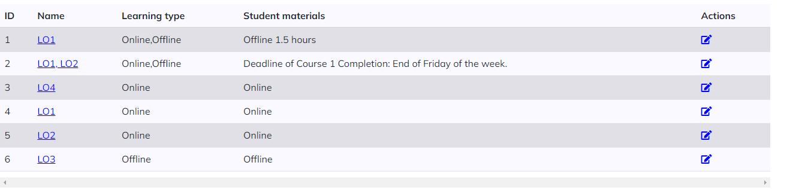
* **Functional Details**: Support various file formats commonly used for data interchange, such as Excel, or XML.
* Validate the format, structure, and integrity of the imported data to prevent errors during the import process.
* Implement mechanisms to handle large datasets and optimise the import performance.

**5. Material Approvals**

**A. Decision Management**

1. **Decision List**

* **Function trigger**: This function will be displayed at home when Staff log in
* **Function description**: This function will be displayed at home when Staff log in
* **Screen layout**:mock-up prototype of the screen, sample below is for the Decision List screen

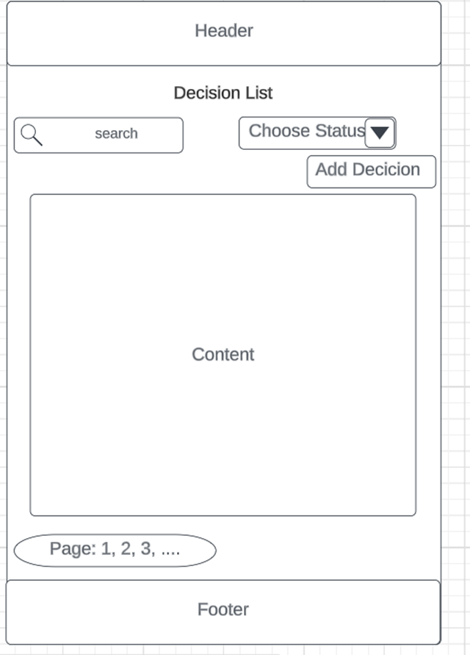

* **Functional Details**: : When the Staff is logged in, the Material Decision will be displayed on the home screen, click on it and we will go to the Decision List page

1. **Decision Details**

* **Function trigger**: When we are on the Decision List page, there will be a Detail Decision display
* **Function description**: Used to describe a particular decision as well as modify that decision.
* **Screen layout**: mock-up prototype of the screen, sample below is for the Detail Decision screen

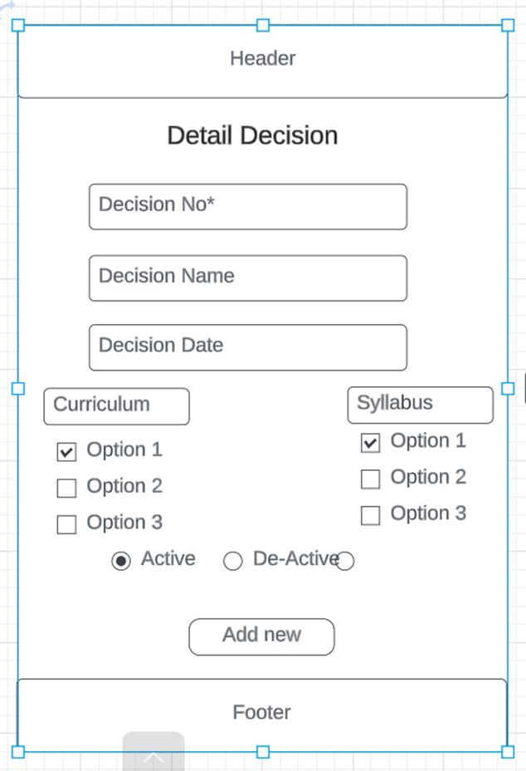

* **Functional Details**: When the staff is in the decision list, just click on the decision No link or the symbol to open the Detail Decision page to view the details of a decision as well as edit it.

1. **New Decision**

* **Function trigger**: When we are on the Decision List page, there will be an Add Decision display
* **Function description**: When we are on the Decision List page, there will be an Add Decision display
* **Screen layout**: When we are on the Decision List page, there will be an Add Decision display

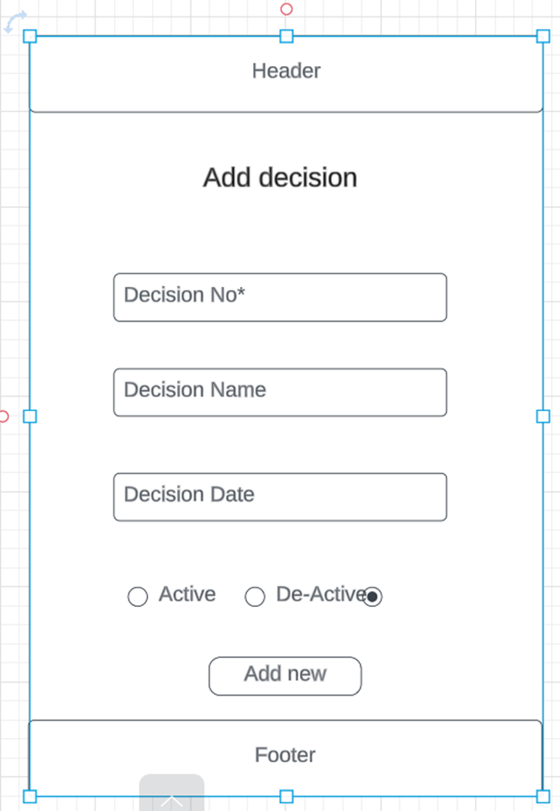

* **Functional Details**: When the staff is in the decision list, just click on the add decision button to open the Add Decision page to add a new Decision.

1. **Decision Overview**

* **Function trigger**: This function is triggered when the user clicks Decision No
* **Function description**: It describes the decision table in detail
* **Screen layout**: mock-up prototype of the screen, sample below is for the Decision Overview screen

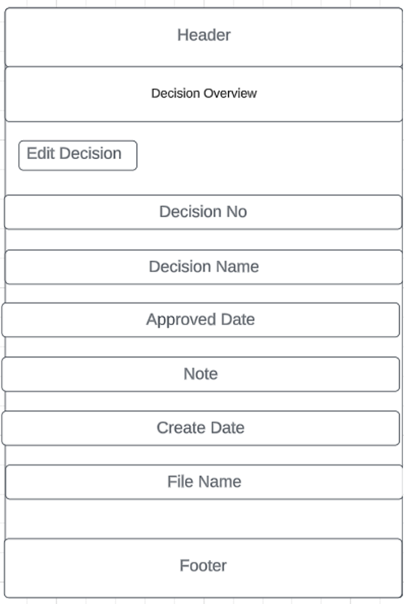

* **Functional Details**: Users who don't need to login can also see the decision overview just go to the pages that have it just click and see the details of the decision table

**C. External system integrations**